Common Conditions of the Upper Back, and Shoulder
Clarkson University Performing Arts Injury Prevention

What is a Musculoskeletal Injury (MSI)?
A musculoskeletal injury is classified as any disorder or condition of the muscles, bones, joint, tendons, ligaments, nerves, blood vessel, or related soft tissues. The Increase in stress and activity on musculoskeletal structures may lead to a strain, sprain, or inflammation. The increased demands on the body contribute to the occurrence of MSI. For example, musicians must spend a large portion of the day practicing/performing which increases the risk for such injuries. The array of physical, professional, and artistic demands of performers can be very stressful on the body; thus, leading to possible MSI-related symptoms.
Risk Factors for MSI:

MUSCULOSKELETAL INJURY

Progression of MSI signs & symptoms in performers
Level I
Pain occurs after class, practice, rehearsal or performance, but the musician performs monthly
Level II
Pain occurs during class, practice, rehearsal or performance, but the musician is not restricted in performing
Level III
Pain occurs during class, practice, rehearsal or performance, and begins to affect some aspects of daily life. Musician alters techniques, decreases duration
Level IV
Pain occurs as soon as the musician participates in class, practice, rehearsal, or performance, and is too severe to continue. Many aspects of daily life and affected
Level V
Pain is continuous during all activities of daily life, and the musician is unable to participate in class, practice, rehearsal, or performance
**If you are level I or II, modify your activities to prevent further progression of symptoms. If you are at level III or higher, seek professional assistance

Take an active role in injury prevention

Controlling risk factors:
- Requires awareness that risk factors exist
- Balance physical and psychological demands.
- Maintain high level of well-being, health, fitness, and nutrition

Recognize and respond to early signs and symptoms:
- Early detection of symptoms allows for:
- Seeking medical assistance
- Referrals to appropriate specialist
- Prevention of further injury and negative impact on daily life.

Helpful Resource for general musician related injury overview and prevention:
- Safety and Health in Arts Production and Entertainment. Preventing Musculoskeletal Injury (MSI) for Musicians and Dancers: A Resource Guide. 2002. Available at http://www.actsafe.ca/wp-content/uploads/resources/pdf/msi.pdf
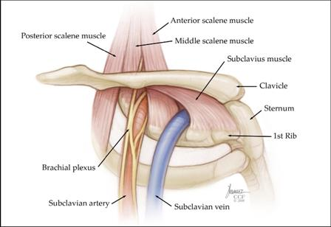
Thoracic outlet syndrome
What it is?
- There is a space between the collarbone and the first rib. If this space becomes narrow it can pinch off blood vessels, muscles and nerves that pass through this area.
Causes:
- Thoracic outlet syndrome is more prevalent in men than women, but anyone can be at risk. People with poor posture, obesity, or injury are at higher risk for this problem. Stress, repetitive arm movements or shoulder movements can also cause it.
- Thoracic outlet syndrome is more common in violinist and guitar players on there left side and flute players on both sides.
Common signs and symptom:
- You many notice with compression of nerves or blood vessels that overhead activities are harder, or that the range of motion in the shoulder is affected.
- If there is pressure on the nerves: there may be an aching in the neck shoulder arm, or hand on the effected side. There can also be numbness, tingling, or pain on the forearm, and on the pinky side of the hand. People may also notice weakness or clumsiness in the hand on the side that is affected.
- If there is pressure on the blood vessels: there can be a redness or swelling in the arm, and because this is a compression of the blood that flows into the arm, the hand and fingers in rare cases can feel cool, and fatigue quickly.
Management:
- Physical Therapy: Postural strengthening and stretching will help to raise the collar bone up from the first rib.
  - For 3 exercises you can try at home: https://www.youtube.com/watch?v=Z4aXRj0uIj4
  - Some other exercises you can try: Corner Stretch - Stand in a corner (about 1 foot from the corner) with your hands at shoulder height, one on each wall. Lean into the corner until you feel a gentle stretch across your chest. Hold for 5 seconds. Neck Stretch - Put your left hand on your head, and your right hand behind your back. Pull your head toward your left shoulder until you feel a gentle stretch on the right side of your neck. Hold for 5 seconds. Switch hand positions and repeat the exercise in the opposite direction. Shoulder Rolls - Shrug your shoulders up, back, and then down in a circular motion. Neck Retraction - Pull your head straight back, keeping your jaw level. Hold for 5 seconds.
  - As with all exercise programs, if any of these movements cause pain, stop immediately.
- Rest. The first step toward recovery is to avoid overhead activity.
- Nonsteroidal anti-inflammatory medicines. Drugs like ibuprofen and naproxen reduce pain and swelling with the approval of your doctor..
Helpful sources:
- American Academy of Orthopedic Surgeons, this link has a lot of great background information http://orthoinfo.aaos.org/topic.cfm?topic=a00336
- Cleveland Clinic, this link has some more details on how to manage and treat this condition http://my.clevelandclinic.org/disorders/thoracic_outlet_syndrome/hic_thoracic_outlet_syndrome.aspx
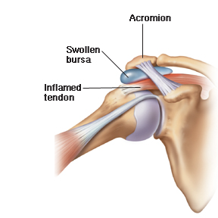
Subacromial bursitis
What it is?
- This is inflammation of the small fluid filled sac, or bursa, which is located under the bones on the top of your shoulder. This bursa helps to allow smooth motion between bones, muscles, tendons, and the skin.
- Bursitis often develops because of an injury, being pinched by other structures in the shoulder, or impingement, and overuse of the muscles surrounding the bursa.
Causes:
- Weakness in the arm
- Overuse of the shoulder like increasing practice time drastically without taking breaks.
- Excessive movements of the shoulder joint (like hypermobility)
- Tears of the surrounding rotator cuff
- Pinching of the bursa
- People who have frequent injuries to the shoulder are at an increased risk for developing subacromial bursitis, as well as people who also are doing frequent overhead living, as well as forceful pulling.
Common signs and symptoms:
- There is pain in the shoulder when the person is performing activity as well as when they are resting. The pain is felt on the outer arm about 4-5 inches down from the top of the shoulder. The pain is described as an aching and can bother the person even interrupt a person’s sleep. The range of motion of the persons is decreased.
Management:
- Rest and avoiding overhead movements is the best way to begin to treat the symptoms.
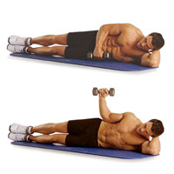
- This can be treated through the use of ice, (pain for last 24 hours) Heat (more than 2 days)
- You can also try this exercise: Side-Lying Single-Arm External Rotation: Lay on the shoulder that doesn’t hurt, bend your top arm so your elbow is at 90 degrees. Keeping your upper arm stationary, slowly rotate your forearm until it points toward the ceiling. Then back to the starting position.
- If the pain continues for more than 3 days you should go to your doctor, or a physical therapist.
Helpful sources:
- Some more information on the management: http://www.sportsinjuryclinic.net/sport-injuries/shoulder-pain/subacromial-bursitis/rehabilitation-subacromial-bursitis
- Great resource for more exercises to try: http://www.med.unc.edu/fammed/fammedcenter/about-us/services/sportsmedicine/Subacromial%20bursitis%20patients.pdf
- American Academy of Orthopedic Surgeons, this link has a lot of great background information http://orthoinfo.aaos.org/topic.cfm?topic=a00032

Bicipital tendonitis
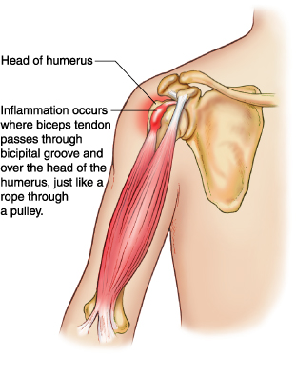
What it is?
- The biceps muscle is in the front of your upper arm. It helps you bend your elbow and rotate your arm. It also helps keep your shoulder stable.
- The biceps muscle has two tendons that attach it to bones in the shoulder. The long head attaches to the top of the shoulder socket and this is the part that usually gets irritated.
Causes:
- This injury is usually caused by a lifetime of overhead activities.
- Overuse of the shoulder like increasing practice time drastically without taking breaks.
- Swimming, tennis, and baseball are some sports examples of repetitive overhead activities.
Common signs and symptoms:
- Pain or tenderness in the front of the shoulder and the pain gets worse with overhead activities,
- An occasional snapping sound or sensation in the shoulder
- Occasionally, the damage to the tendon can result in a tendon tear which is referred to as "Popeye" bulge in the upper arm
Management:
- Rest. The first step toward recovery is to avoid overhead activity.
- Ice. Apply cold packs for 20 minutes at a time, several times a day, to keep swelling down. Do not apply ice directly to the skin.
- Physical therapy: Specific stretching and strengthening exercises restore range of motion and strengthen your shoulder.
  - For some exercise you can try at home to help relieve pain try this exercise video https://www.youtube.com/watch?v=1G_btwdKcVc
- Nonsteroidal anti-inflammatory medicines. Drugs like ibuprofen and naproxen reduce pain and swelling with the approval of your doctor.
- If your condition does not improve with nonsurgical treatment, your doctor may suggest surgery. Surgery may also be necessary if you have other shoulder problems.

Helpful sources:
- American Academy of Orthopedic Surgeons, this link has a lot of great background information http://orthoinfo.aaos.org/topic.cfm?topic=a00026
- Physioworks has some great information on the basics of management http://physioworks.com.au/injuries-conditions-1/biceps-tendinitis
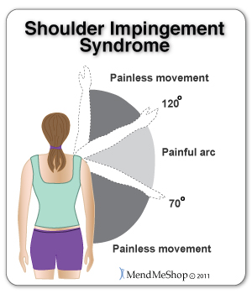
Supraspinatus impingement
What it is?
- One of the most common causes of shoulder pain in musicians
- This happens when there is instability, or increased movement of the shoulder joint which cause compresses soft tissue in the joint space
- The supraspinatus tendon and the bursa, can be pinched when the arm is raised out to the side
- With repetitive impingement, the tendons and bursa can become inflamed and painful
Causes:
- Overhead movement in that painful space
- Poor posture of the shoulder
- Laxness of the ligaments and weakness of the muscles in the shoulder
- The rotator cuff has to work harder because of instability and weakness, which means that you can get injury when the bones of the shoulders rise up into the space and pinch soft tissue
Common signs and symptoms:
- Minor pain that is present both with activity and at rest, even at night when laying on that arm
- Pain radiating from the front of the shoulder to the side of the arm
- Sudden pain with lifting and reaching movements
- overhead activities may have pain with bow work between 70º and 120º
- Loss of strength and motion
- Difficulty doing activities that place the arm behind the back, such as buttoning or zippering
Management:
- Rest. First rest and modify activity modification, like avoiding overhead activities.
- Non-steroidal anti-inflammatory medicines. Drugs like ibuprofen and naproxen reduce pain and swelling.
- Physical therapy. The focus will be strengthening of the shoulder muscles
- If nonsurgical treatment does not relieve pain, your doctor may recommend surgery.
- For general strengthening exercises refer to the Strengthening for Musicians handout
Helpful sources:
  - http://www.scoi.com/rotator-cuff.php
  - http://orthoinfo.aaos.org/topic.cfm?topic=a00032
  - Shoulder Joint and Muscle Exposure in Violin Musicians: a three dimensional kinematic and electromyographic exposure variation analysis; by Jonathan F Reynolds

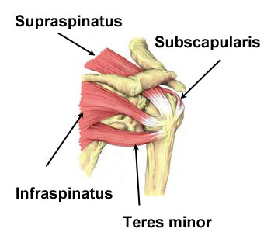
Rotator cuff sprains and strain
What it is?
- The rotator cuff is made up of 4 different muscles and their tendons. These structures provide the stability and strength of the shoulder joint that allows for the shoulder to move. A sprain (ligament) or strain (tendon) of the rotator cuff is when the structure is stretched or torn.
Causes:
- These are caused by inflammation or injury to the rotator cuff from trauma, overuse, poor posture, or weakness.
- These things can cause irregular movements of the shoulder and which can lead to pinching of the surrounding structures.
- When these structures are pinched continued activity can cause the structures to tearing.
Common Signs and Symptoms:
- An ache in the shoulder, with pain is increased when lying on the affected arm
- Sharp pains when trying to reach behind your back
- Weakness when lifting objects or rotating your arm
- Crackling sensations within the shoulder joint when the arm is raised to the side while bent at the elbow and moved forwards and backwards
- If you can raise your arm over your head without pain but you experience inability to slowly lower your arm or pain doing so this could indicate a tear
Management:
- Rest: take a break from the activity this is the first way to treat pain.
- Inflammation and pain management: Use an icepack for 10-15 minutes with a towel underneath to protect your skin from frostbite, and consult your doctor about pain medications and anti-inflammatory.
- Stretching and Strengthening: when the symptoms have started to get better you can being strengthening. If there is pain or symptoms get worse consult a doctor or physical therapist.
  - For more information on exercises and stretches try this link: https://uhs.berkeley.edu/home/healthtopics/PDF%20Handouts/Rotator%20Cuff%20Sprain%20and%20Strains.pdf
Helpful sources:
- American Academy of Orthopedic Surgeons: information on the difference between strains and sprains http://orthoinfo.aaos.org/topic.cfm?topic=A00111
- American Academy of Orthopedic Surgeons, background information on rotator cuff tears http://orthoinfo.aaos.org/topic.cfm?topic=a00064
- Try this link for more information on deciding if your symptoms match this condition http://www.sportsinjuryclinic.net/sport-injuries/shoulder-pain/rotator-cuff-strain/assessment-rotator-cuff-injury
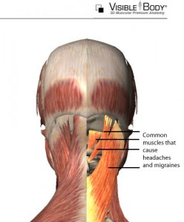
Cervicogenic Headache
What it is?
- A cervicogenic headache is a headache that is caused by the neck.
- The headache usually starts as intermittent episodes and then progresses to an almost continuous pain.
- Pain may be triggered or made worse by neck movement or a particular neck position
Causes:
- One of the main causes of a carcinogenic headache is too much stress to your neck and spine. Which can be from bad posture
- Cervicogenic headache usually starts in in the back of the head
- These types of headaches are commonly a result of other things like irritated muscles from bad posture or even whiplash
Common signs and symptoms:
- Steady, non-throbbing pain at the back and base of the skull, sometimes extending down to the neck and between the shoulder blades.
- The pain can also be located behind the brows and forehead.
- Pain usually starts after a sudden neck movement, such as a sneeze.
- Nausea/vomiting,
- Dizziness
- Blurred vision
- Becoming very sensitive to light or sounds
- The neck also becomes very stiff and the patient may have trouble moving.
Management:
- First thing to do is find the cause of your headaches and to try and relieve it
- NSAIDs (ibprofian), aspirin, and acetaminophen can be used to try and control pain but you should talk to your doctor before taking medication
- Trigger point release and self-massage, see self-care handout for more information. Physical therapist can help you refine how you perform these or even do them to you
- Spinal manipulation done by a certified practitioner such as a physical therapist
- Physical therapist can prescribe specific exercise for you individually but you can also try this link for 3 recommended exercises
  - https://www.youtube.com/watch?v=h5MvX50zTLM
- Invasive procedures include trigger point injections, occipital nerve blocks, facet joint blocks, segmental nerve root blocks, and diskography; and behavioral approaches.
Helpful sources
- Some great general background information http://pain-medicine.med.nyu.edu/patient-care/conditions-we-treat/cervicogenic-headache
- If you want some more detailed information try this link http://www.spine-health.com/video/cervicogenic-headache-video

Sternocleidomastoid trigger points
What is it?
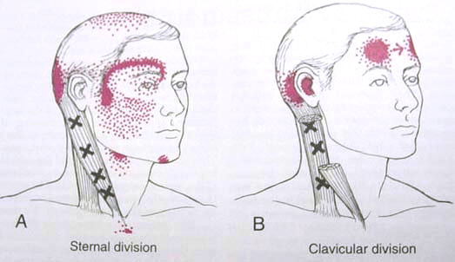
- The sternocleidomastoid is a muscle that will bend the head forward when the muscles on both sides are used, or when only the muscle on one side of the neck us used will rotate the head and tilt it upward
Causes:
- Overhead activities
- Looking up for a long period of time
- Poor neck posture such as having a forward head
- Trauma like whiplash, or a fall
- Chronic cough or infection
Common Signs and Symptoms:
- Tension headaches that occur in the forehead, pain on top and back of the head or cheek
- Soreness of the muscle when touched
- Tearing and redness of the eye, or blurred vision, and behind the eye
- Dizziness, nausea, and loss of appetite, and sweating and cool sensation on forehead
- Earaches
Management:
- Avoid overhead work and prolonged periods of looking up
- Practicing good posture
- Using proper diaphragmatic breathing techniques
- Preventing colds and other infections that will increase coughing
- See a specialist if body asymmetries are present
- Helpful sources:
- The Trigger Point Therapy Workbook: Your Self-Treatment Guide for Pain Relief, by Clair Davies & Amber Davies.
- When Movement Hurts: A Self-Help Manual for Treating Trigger Points, by Barbara J. Headley.
- Pain Relief with Trigger Point Self-Help by Valerie DeLaune
- Please see Learn How to Manage your Trigger points handout for more information

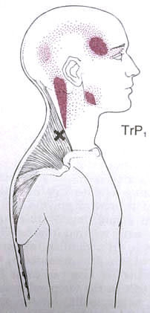
Trapezius
Function: Moves the shoulder girdle and shoulder blade in various directions.
- Common Symptoms
Upper trapezius
- Headaches, facial, temple, jaw pain
- Pain behind the eye and dizziness
- Neck pain
- Limited range of motion
Middle trapezius
- Mid back and shoulder pain
- Headaches at base of skull
- Burning sensation near spine

Lower trapezius
- Mid back, neck, upper shoulder pain and headaches at base of the scull
- Referred pain to shoulder blade, inside of arm
- Causes:
- Poor posture and ergonomics
- Clothing or anything that places constricting pressure on the muscle (ex. backpack, purse, etc.)
- Certain sports with sudden one-sided movements
- Structural abnormalities such as asymmetrical leg length, pelvis height, etc.)
- Fatigue
- Management
- Improvements in ergonomics in the workplace
- Postural alterations
- Practice relaxation techniques
- Minimize direct pressure on the muscle
- Modification or decreased participation in sports that provoke symptoms
- Address fatigue problems
- Helpful sources:
  - The Trigger Point Therapy Workbook: Your Self-Treatment Guide for Pain Relief, by Clair Davies & Amber Davies.
  - When Movement Hurts: A Self-Help Manual for Treating Trigger Points, by Barbara J. Headley.
  - Pain Relief with Trigger Point Self-Help by Valerie DeLaune
  - Please see Learn How to Manage your Trigger points handout for more information

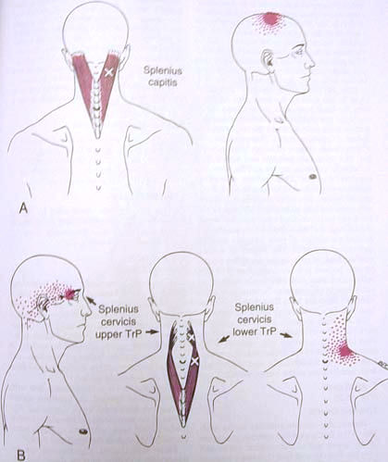
Splenius Capitus and Splenius Cervicis
Function: Rotates the head and brings head back up from forward position; provide stabilization
- Common Symptoms
- Referred pain to top of head (Capitis)
- Referred pain throughout inside of head
- Pain behind the eye
- Pain in back of skull
- Pain at the junction of the neck and top of shoulder
- Decreased neck range of motion
- Blurred vision
- Causes:
- Poor posture, with Prolonged awkward position or looking up
- Poor ergonomics during work
- Forward head posture
- Structural problems (ex. kyphosis)
- Exposure to cold temperatures while muscle is fatigued
- Traumatic injuries
- Sports activities that involve rotating of the head
- Restrictive clothing
- Depression
- Management
- Practice proper posture: Sit upright, with head held directly over trunk and back well supported Invest in pillows or other objects that would facilitate proper spine alignment
- Postural retraining exercises
- Correct body asymmetries
- Avoid cold drafts; try to keep neck warm
- Avoid head rotating activities, modification of sport activities as necessary
- Be aware of restrictive clothing
- Seek counseling for depression if applicable.
- Helpful sources:
  - The Trigger Point Therapy Workbook: Your Self-Treatment Guide for Pain Relief, by Clair Davies & Amber Davies.
  - When Movement Hurts: A Self-Help Manual for Treating Trigger Points, by Barbara J. Headley.
  - Pain Relief with Trigger Point Self-Help by Valerie DeLaune
  - Please see Learn How to Manage your Trigger points handout for more information

Levator Scapula
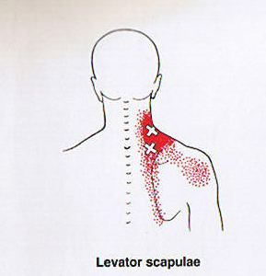
Function: Shrugs shoulder and helps rotate head
- Symptoms:
- Neck, shoulder, & shoulder blade pain
- Limited neck flexion or rotation
- Tension headache
- Other diagnoses with similar symptoms:
- Stiff neck
- Neck (cervical) strain
- Neck disc disease
- Causes:
- Prolonged shoulder tension
- Holding phone between ear and shoulder
- Carrying heavy purse or book bag
- Emotional stress, tension, anger, or fear
- Prolonged posture with head turned, as in typing
- Respiratory infection
- Management:
- Take breaks when working at computer; use armrests
- Face forward without head rotated
- Carry less weight
- Learn stress reduction techniques
- Helpful sources:
  - The Trigger Point Therapy Workbook: Your Self-Treatment Guide for Pain Relief, by Clair Davies & Amber Davies.
  - When Movement Hurts: A Self-Help Manual for Treating Trigger Points, by Barbara J. Headley.
  - Pain Relief with Trigger Point Self-Help by Valerie DeLaune
  - Please see Learn How to Manage your Trigger points handout for more information

Scalenes
Function: Stabilizes the cervical spine and elevates the first and second ribs during inhalation
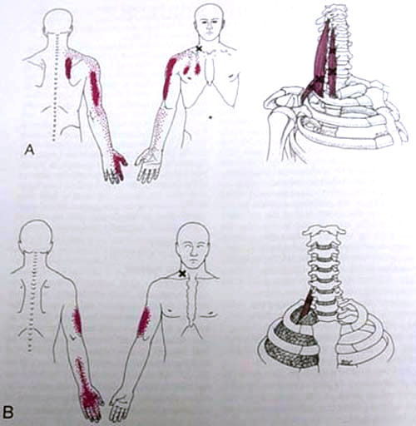
- Common symptoms:
- Referred pain to chest, mid back, and/or over the outside, back, and front of the arm and into the wrist and hand
- Pain may interrupt sleep, relieved by sleeping sitting up
- Decrease range of motion when turning and bending the head
- Numbness, tingling, and loss of sensation in fingers and hand
- Finger stiffness
- Causes:
- Excessive pulling or lifting activities
- Poor body mechanics when carrying large objects
- Traumatic injuries
- Trigger points in SCM and levator scapula
- Improper breath techniques
- Asymmetries of body structures (legs, pelvis, spine, ribs)
- Management:
- Avoid activities that require lifting and pulling heavy objects
- Prevent excessive turning of the head to one side
- Learn proper breathing techniques
- Address surround trigger points
- Seek specialist if structural asymmetries exist.
- Helpful sources:
  - The Trigger Point Therapy Workbook: Your Self-Treatment Guide for Pain Relief, by Clair Davies & Amber Davies.
  - When Movement Hurts: A Self-Help Manual for Treating Trigger Points, by Barbara J. Headley.
  - Pain Relief with Trigger Point Self-Help by Valerie DeLaune
  - Please see Learn How to Manage your Trigger points handout for more information

Rhomboids
Functions: Stabilizes the shoulder blade and brings it toward the spine
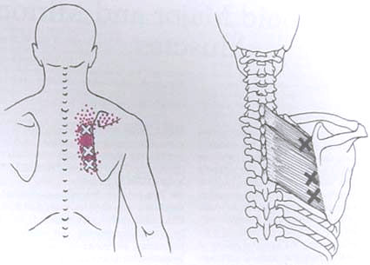
- Common symptoms
- Localized pain in upper/mid back, between edge of shoulder blade and spine
- Discomfort is typically superficial and achy
- Symptoms aggravated by lying on the same side or by reach forward
- Snapping noises upon movement of the shoulder blade
- Rounded shoulders
- Causes
- Poor posture
- Constantly leaning forward for long periods of time
- Rounded shoulders
- Tight pectoral muscles
- Persistent discouragement or sad (leads to slumping of the shoulders)
- Structural problems
- Scoliosis
- Management
- Learn proper ergonomics and body mechanics
- Address additional trigger points in pectoral muscle if applicable
- Practice proper breathing techniques
- Learn ways to control degree of depression/sadness if applicable
- Address structural abnormalities with appropriate specialist
- Helpful sources:
  - The Trigger Point Therapy Workbook: Your Self-Treatment Guide for Pain Relief, by Clair Davies & Amber Davies.
  - When Movement Hurts: A Self-Help Manual for Treating Trigger Points, by Barbara J. Headley.
  - Pain Relief with Trigger Point Self-Help by Valerie DeLaune
  - Please see Learn How to Manage your Trigger points handout for more information

