**Common Conditions of the Hand, Wrist, and Elbow**

__________________________________________________________________

**What is a Musculoskeletal Injury (MSI)?**

A musculoskeletal injury is classified as any disorder or condition of the muscles, bones, joint, tendons, ligaments, nerves, blood vessel, or related soft tissues. The Increase in stress and activity on musculoskeletal structures may lead to a strain, sprain, or inflammation. The increased demands on the body contribute to the occurrence of MSI. For example, musicians must spend a large portion of the day practicing/performing which increases the risk for such injuries. The array of physical, professional, and artistic demands of performers can be very stressful on the body; thus, leading to possible MSI-related symptoms.

**Risk Factors for MSI:**

**MUSCULOSKELETAL INJURY**

|  |
| --- |
| Progression of MSI signs & symptoms in performers |
| Level I |
| Pain occurs after class, practice, rehearsal or performance, but the musician performs monthly |
| Level II |
| Pain occurs during class, practice, rehearsal or performance, but the musician is not restricted in performing |
| Level III |
| Pain occurs during class, practice, rehearsal or performance, and begins to affect some aspects of daily life. Musician alters techniques, decreases duration |
| Level IV |
| Pain occurs as soon as the musician participates in class, practice, rehearsal, or performance, and is too severe to continue. Many aspects of daily life and affected |
| Level V |
| Pain is continuous during all activities of daily life, and the musician is unable to participate in class, practice, rehearsal, or performance |

**If you are level I or II, modify your activities to present further progression of symptoms. If you are a level III or higher, seek professional assistance.

**Take an active role in injury prevention**

**Controlling risk factors:**

* Requires awareness that risk factors exist
* Balance physical and psychological demands.
* Maintain high level of well-being, health, fitness, and nutrition

**Recognize and respond to early signs and symptoms:**

* Early detection of symptoms allows for:
* Seeking medical assistance
* Referrals to appropriate specialist
* Prevention of further injury and negative impact on daily life.

Helpful Resource for general musician related injury overview and prevention:

* Safety and Health in Arts Production and Entertainment. Preventing Musculoskeletal Injury (MSI) for Musicians and Dancers: A Resource Guide. 2002. Available at <http://www.actsafe.ca/wp-content/uploads/resources/pdf/msi.pdf>

**Conditions of the Hand**

**Focal Hand Dystonia “Musician’s Cramp”**

**What is it?**

* Focal hand dystonia is a malfunction of a muscle at a specific location resulting in the muscles to contract and spasm involuntarily. This may lead to repetitive movements or abnormal postures. It can affect just one muscle or it may affect a muscle group as a whole. Among musicians, focal hand dystonia most commonly affects hands and fingers of string and keyboard players. Dystonia is typically present in context specific tasks. For example, a dual string player may experience symptoms while playing violin, however, may be symptom free while playing other string instruments. Typically, this condition does not present until the fourth decade and is highly prevalent in professional musicians because of the high exposure to repetitive practice over time.

**Causes**

* Focal hand dystonia can affect any profession requiring repetitive movements, but is the most common among musicians.
* At this time, the exact cause is not well understood. However, it is hypothesized that the areas in the brain responsible for communicating movement patterns to the body is impaired. This leads to abnormal function of the hand.
* Keyboard and guitar players
  + Focal hand dystonia due to
    - Straining small hand muscles
    - Lateral finger movement and finger spread
    - Stress on finger flexors at large knuckles
    - Loud repeated octaves or chords
* String players
  + Focal hand dystonia due to
    - Pressure on strings from left wrist flexors
    - Extensors of right wrist while bowing
    - Small rapid bow movements
    - Sustained rapid tremolo causes increased demands on flexors and extensors
* Other instruments
  + Focal hand dystonia due to
    - Sustained extension to hold instrument while allowing fingers to curl into position for fingering.

**Common signs and symptoms**

* Most affected musicians describe symptoms such as:
* Cramping
* Stiffness
* Involuntary bending or straightening of the joint
* Sense of fatigue
* Loss of coordination
* May or may not be painful
* Referred pain with cramping and spasm
* Interferes with ability to play
* Curling of fingers

**Management:**

* Symptoms of this condition are manageable; however, there is currently no cure.
* Physical Therapy
* Stretching exercises of the hand and fingers to improve flexibility and range of motion necessary for functional activities.
* Hand and finger strengthening exercises to strengthen weakened muscles that may be under-utilized.
* Neuromuscular electrical stimulation to assist in stimulating and strengthening the muscles of the hands and fingers.
* Options for symptoms management include the following:
* Splinting
* Ergonomic changes ( ex. changing position of keys on a wind instrument, using opposite hand for bowing)
* Medications (as prescribed by a physician)

Helpful Sources:

* Lie-Nemeth T. Focal dystonia in musicians. *Phys. Med. Rehabil Clin N Am*. 2006; 17: 781-787.
* The Dystonia Society at [www.dystonia.org](http://www.dystonia.org)
* The Dystonia Medical Research Foundation at [www.dystonia-foundation.org](http://www.dystonia-foundation.org)
* Carsley C. Musicians and musculoskeletal injuries. <http://www.mcgill.ca/music/sites/mcgill.ca.music/files/Musicians_and_Musculoskeletal_injuries.pdf>.

**De Quervain’s Tenosynovitis**

**What is it?**

* De Quervain’s Tendinosis refers to swelling of the tendons around the base of the thumb due to irritation from repetitive movements. This swelling can cause irritation and tenderness along the thumb and into the forearm because there is a decrease in space for the tendons to pass through a small area or tunnel near the wrist.

**Causes**

* Inflammation is most commonly caused by work-related activities, repetitive gripping and pinching and direct injury.
* Most common in musicians who play the oboe, clarinet, bassoon, flute, pianists and bowing instruments. Prevalence is high among these instruments due to the positioning of the thumb to support and maneuver the instrument.
* Those who participate in extended practice of complicated and technically demanding pieces are more vulnerable to injury as they may present with isolate swollen tendons in either hand or wrist particularly among violinists, extensive vibratos have been shown to develop tender swollen tendons of the left hand.

**Common signs and symptoms**

* Most affected musicians describe symptoms such as:
* Pain over thumb side of wrist (pain may appear gradually or suddenly)
* Pain can travel up the forearm but pain is usually worse when the hand and thumb are in use.
* Swelling over the thumb side of the wrist
* A “catching or “snapping” sensation when moving the thumb
* 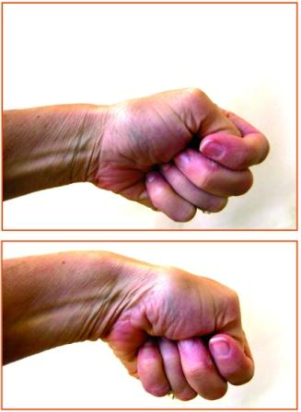Difficulty moving the thumb and wrist due to pain and swelling

Pain with this motion (a hammering motion with the thumb in the fist) is characteristic of de Quevain syndrome.

* Painful firm grip or twisting motion
* Painful to move thumb away from hand

**Management:**

* Acute stage: absolute rest is recommended for 24-48 hours, along with ice to the base of the thumb, elevation and oral or topical NSAIDS. May also use a thumb splint
* Initial treatment focuses on identification and minimization of aggravating activities. This may include:
* A change of technique or hand posture
* Shorter playing sessions
* More frequent breaks to allow for rest and recovery.
* Chronic stage: heat, deep massage, playing should be limited; practice sessions should be restricted to no longer than 5-10 minutes with no more than 3-4 sessions per day. As condition eases the amount of playing should gradually increase.
* Physical therapy
* Strengthening exercises when pain has subsided. Resistive exercises of the hand will help increase metabolism, speed repair, and prepare musicians to meet physical demands of daily practicing.
* Modalities such as ultrasound, superficial heat, and cold.
* Resolution of tendinitis is slow and many patients may experience intermittent symptoms for 12-18 months.

Helpful sources:

* Winspur I. *The musician’s hand: a clinical guide*. Florida: Taylor and Francis; 1998.
* Carsley C. Musicians and musculoskeletal injuries. <http://www.mcgill.ca/music/sites/mcgill.ca.music/files/Musicians_and_Musculoskeletal_injuries.pdf>.
* American Academy of Orthopedic Surgeons at [www.orthoinfo.aaos.org](http://www.orthoinfo.aaos.org)
* American Society of Surgery of the Hand at [www.assh.org](http://www.assh.org)

**Conditions of the Wrist**

**Carpal Tunnel Syndrome**

**What is it?**

* Carpal Tunnel Syndrome is the most common nerve entrapment condition involving occlusion of the median nerve through the wrist. Typical structural alignment of the wrist includes several carpal bones and a ligament that form what’s called a “carpal tunnel.” Included in the carpal tunnel lies the median nerve as well as several tendons of muscles that are involved with movement of the fingers. The purpose of the median nerve is to provide sensation to the thumb, index and middle fingers. Carpal tunnel syndrome can be a common occurrence for musicians due to repetitive wrist movements leading to inflammation within the carpal tunnel.

**Causes of Carpal Tunnel Syndrome**

* Excessive movement of the wrist and fingers irritates the flexor tendons in the wrist leading to inflammation and pressure on the median nerve.
* Particularly associated with certain tasks including:
  + Awkward hand positions
  + Strong gripping
  + Mechanical stress on the palm
  + vibration
* Additional causes include:
  + Heredity – carpal tunnels are smaller in some people which could lead to increased risk
  + Hormonal changes – example: pregnancy
  + Age – more common in older people
  + Medical conditions – including diabetes, rheumatoid arthritis, thyroid gland imbalance
* Very common in the left hand of violinists, violists and guitar players

**Common signs and symptoms**

* Crowding of the median nerve leads to signs and symptoms including
  + Numbness, tingling and pain in the hand
  + A shock-like feeling in the thumb, index and middle finger
  + Odd sensations and pain traveling up the arm toward the shoulder
  + Symptoms begin gradually
  + Symptoms frequently occur when holding an object
  + Often times reported symptoms are worst at night
  + Feelings of clumsiness or weakness
* Be sure to know that not all pain in the hand is carpel tunnel syndrome. Pain may actually be the result of tendonitis or surrounding trigger points.

**Self Detection Techniques**

[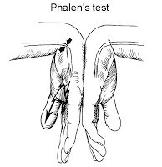](http://4.bp.blogspot.com/-02KR7HiXOtM/UeOFPDtY1LI/AAAAAAAAAIA/acMkcHFFyes/s1600/carpal-tunnel-phalens.jpg) [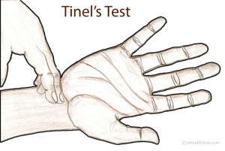](http://www.ehealthstar.com/wp-content/uploads/2013/09/Tinels-Test-Sign.jpg)

Bend wrist and maintain hands in a 90 degree angle, pushing the back of both hands together, for about one minute. A positive sign of Carpal Tunnel Syndrome would be numbness and tingling sensation in the thumb, index and middle fingers.

Rapidly tap just below your palm on your wrist for about one minute. A positive test is numbness or tingling in the thumb, index or middle fingers.

**Management:**

* Bracing or splinting – wearing a brace or splint while sleeping can help keep the wrist in a neutral position. This prevents worsening of symptoms at night. Splints can also be worn during activities that aggravate the symptoms.
* Activity changes – changing patterns of hand use to avoid positions that aggravate the symptoms. Modifying problematic positions would be beneficial in slowing or stopping progression of the condition.
* Physical therapy
* Strengthening exercises for the muscles in the hand, fingers, and forearm.
* Stretching exercises to improve flexibility of the wrist, hand, and fingers (flexors)
* Median nerve guides to promote correct movement of the nerve through the carpel tunnel and to prevent adhesions from forming.
* Heat and cold application
* Medications or NSAIDS
* Surgery – only considered if cannot find symptom relief with non-surgical techniques

Helpful Sources:

* American Academy of Orthopedic Surgeons at [www.orthoinfo.aaos.org](http://www.orthoinfo.aaos.org)
* Carsley C. Musicians and musculoskeletal injuries. <http://www.mcgill.ca/music/sites/mcgill.ca.music/files/Musicians_and_Musculoskeletal_injuries.pdf>.

**Ulnar Nerve Entrapment**

**What is it?**

* Ulnar nerve entrapment is a painful disorder of the arm and hand caused by compression of the ulnar nerve in the arm. Typically, the ulnar nerve travels from the neck down to the pinky side of the arm and into the wrist and hand. It provides sensation to the pinky side of the wrist and hand as well as to the 4th and 5th digits.

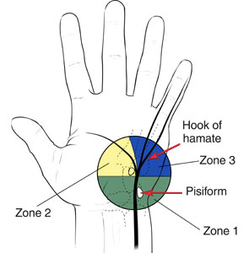**Causes of ulnar nerve entrapment**

* Compression of the ulnar nerve is the primary cause of ulnar nerve entrapment in relation to the wrist.
* A ganglion, which is a benign soft tissue tumor, commonly originates in the wrist joint. This leads to increased pressure on the ulnar nerve, leading to entrapment.
* Other frequent causes include repetitive trauma/pressure to the area as well as direct injury to the nerve.
* The habits of musicians, including repetitive movement and awkward postures, predispose these individuals to wrist ganglions. This leads to symptoms associated with ulnar nerve entrapment due to imbalanced playing.

**Common signs and symptoms:**

* Abnormal sensations, such as numbness and tingling, in the 4th and 5th digits
* Pain in 4th and 5th digits
* Weakness and loss of coordination of fingers
* Difficulty holding objects and opening jars

**Presentation of this condition can often be mistaken for cubital tunnel syndrome. Refer to cubital tunnel syndrome under elbow conditions later in this handout for more information.

**Management**

* Alteration of abnormal and awkward postures which allow for decrease stress on the nerve.
* Decreasing degree of repetitive motions while playing instrument
* Splinting (only provides short term relief)
* Physical therapy
* Strengthening exercises of the elbows, wrists and hands
* Ulnar nerve glides to promote appropriate movement of the nerve through the wrist.
* NSAIDs for inflammation control
* Surgery or other medical procedures to decrease number or size of wrist ganglions.

Helpful Sources:

* Winspur I. *The musician’s hand: a clinical guide*. Florida: Taylor and Francis; 1998.
* John Hopkins Medical Center at [www.hopkinsmedicine.org](http://www.hopkinsmedicine.org)
* American Academy of Orthopedic Surgeons at [www.orthoinfo.aaos.org](http://www.orthoinfo.aaos.org)

**Conditions of the Elbow**

**Lateral Epicondylitis (tennis elbow)**

**What is it?**

* Lateral epicondylitis is a painful condition involving the tendons that attach to the bone on the outside part of the elbow, known as the lateral epicondyle. The muscles that attach to this area include the wrist extensors, which help to extend and stabilize the wrist, turn the hand palm-side-up, and lift an object. This condition is associated with inflammation of the extensor tendon.

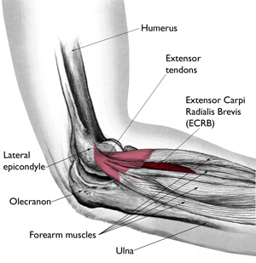

**Causes of Lateral Epicondylitis**

* Caused by overuse, which can be both non-work and work related. Any repetitive activities that place stress on the attachment site of the extensor tendon leads to inflammation and irritation of the lateral epicondyle.
* Often occurs during movements that require the fingers to be extended at the same time that the wrist is being extended. Leads to overall strain on the muscle.
* Additional cause includes direct trauma to the elbow
* Musicians that are most at risk for lateral epicondylitis include those who play the following instruments:
  + - Clarinet, oboe, trombone, percussion, keyboard

**Common signs and symptoms**

* Tenderness, pain, and swelling at the location of the lateral epicondyle
* Increased pain during the night hours that may wake you up at night
* With activity, pain usually starts at the elbow and may travel down to the forearm and the hand.
* Bending the wrist upward or gripping aggravates symptoms
* Decreased grip strength and weak upward bend of the wrist.

**Management**

* The sooner the injury is identified, the quicker the recovery and the greater the chance of full recovery.
* An ice and stretching protocol should be implemented. Consult a physician or physical therapist for protocol recommendations.
* Frequent stretch breaks (every 45-60 minutes) to assist with relaxing working muscles and improving flexibility and circulation.
* Activity modification to minimize repetitive stresses.
* Recognizing current techniques
* Make minor postural changes
* Awareness of body in relation to the instrument
* Self massage over the medial epicondyle will promotion circulation of blood and nutrients to site of injury.
* Bracing over the back of the forearm can help relieve systems by relaxing and resting the muscles and tendons.
* Taping
* Helps to relieve pressure and aids with stability
* Consult a physician or physical therapist for taping recommendations.

Helpful Resources:

* American Academy of Orthopedic Surgeons at [www.orthoinfo.aaos.org](http://www.orthoinfo.aaos.org)
* American Society for Surgery of the Hand at [www.assh.org](http://www.assh.org)
* Safety and Health in Arts Production and Entertainment. Preventing Musculoskeletal Injury (MSI) for Musicians and Dancers: A Resource Guide. 2002. Available at <http://www.actsafe.ca/wp-content/uploads/resources/pdf/msi.pdf>

**Medial Epicondylitis (Golfer’s Elbow)**

**What is it?**

* Medial epicondylitis is a condition that causes pain on the inner side of the elbow, known as the medial epicondyle. This is the location at which the tendons of the forearm flexor muscles attach. The actions of these muscles include bending the wrist downward and gripping objects.

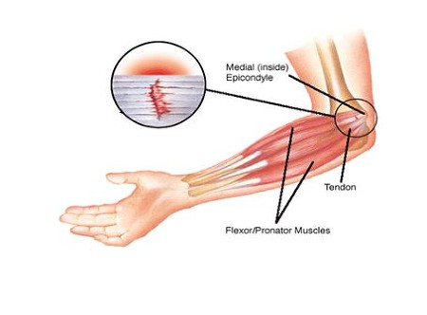

**Causes of Medial Epicondylitis**

* Most common cause is overuse of the flexor muscle
* Activities requiring repeated gripping and wrist flexion, or when there is repetitive finger flexion while the wrist is flexed is the most common mechanism for injury.
* Repetition causes strained muscles, which leads to the involved muscles becoming inflamed.
* The overuse causes small tears around the attachment of tendons to the medial epicondyle which may impair muscle function.
* Harp players have been known to be susceptible to medial epicondylitis in the left arm. Percussion and keyboard players have the likelihood of developing the condition in both arms.

**Common signs and symptoms**

* Pain, tenderness and swelling on the inner side of elbow (medial epicondyle)
* Numbness or tingling that radiates into one or more fingers, usually the 4th and 5th digits. This symptom may also be a sign of cubital tunnel syndrome. Refer to next page for more information.
* Stiffness/pain of the elbow, increased when making a fist
* Aggravation of symptoms when bending the wrist downward and griping objects
* Weakness of the hands and wrist

**Management**

* The sooner the injury is identified, the quicker the recovery and the greater the chance of full recovery.
* An ice and stretching protocol should be implemented. Consult a physician or physical therapist for protocol recommendations.
* Frequent stretch breaks (every 45-60 minutes) to assist with relaxing working muscles and improving flexibility and circulation.
* Activity modification to minimize repetitive stresses.
* Recognizing current techniques
* Make minor postural changes
* Awareness of body in relation to the instrument
* Self massage over the medial epicondyle will promotion circulation of blood and nutrients to site of injury.
* Bracing can help relieve systems by resting the muscles and tendons and providing stabilization
* Taping
* Helps to relieve pressure and aids with stability
* Consult a physician or physical therapist for taping recommendations.

Helpful Resources:

* Safety and Health in Arts Production and Entertainment. Preventing Musculoskeletal Injury (MSI) for Musicians and Dancers: A Resource Guide. 2002. Available at <http://www.actsafe.ca/wp-content/uploads/resources/pdf/msi.pdf>
* Mayo Clinic at [www.mayoclinic.org](http://www.mayoclinic.org)

**Cubital Tunnel Syndrome**

**What is it?**

* Cubital Tunnel Syndrome is associated with compression of the ulnar nerve at the inner side of the elbow (medial epicondyle). The ulnar nerve travels from the shoulder to behind the elbow and into the forearm, wrist and fingers. The location at which it travels behind the elbow is known as the “funny bone.” The ulnar nerve is particularly susceptible to compression at the elbow because it must travel through the cubital tunnel which is a narrow space with very little protection. This nerve provides sensation to the pinky side of the wrist and hand as well as to the 4th and 5th digits.

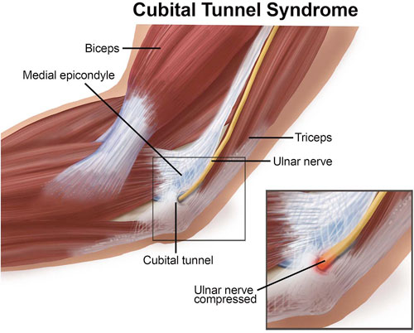

**Causes of Cubital Tunnel Syndrome**

* Due to the location of the ulnar nerve often times the nerve can be irritated with repetitive elbow bending for long periods of time. This leads to significant stretching of the ulnar nerve around the bony medial epicondyle.
* Fluid build-up within the elbow can cause inflammation which provides direct pressure on the nerve
* Direct trauma to the elbow
* Repetitive contractions of the muscles surrounding the elbow joint can narrow the cubital tunnel. This ultimately leads to further compression of the ulnar nerve.
* Musicians who play the violin or viola are highly susceptible to cubital tunnel syndrome in their left arms due to repetitive bending of the elbow during bowing.

**Common signs and symptoms**

* Sensation of your ring and pinky finger “falling asleep” particularly when the elbow is bent
* Numbness and tingling in the ring and pinky finger
* Symptoms may come and go and occur more frequently when the elbow is bent during various activities or while sleeping
* Decreased grip strength
* Decreased finger coordination
* Muscle atrophy (loss of muscle mass) in pinky side of the palm

**Management**

* Early identification of cubital tunnel syndrome will increase the chance of a full recovery
* Initial treatment should include identifying and minimizing aggravating activities
* Changing technique or hand posture (minimizing the degree of elbow bending while playing or holding instrument)
* Shorter playing sessions
* Taking frequent breaks to allow for rest and recovery
* Frequent ice application for inflammation control
* Stretching of the forearm muscles
* Nerve glides will assist with directing the ulnar nerve through the cubital tunnel
* As prescribed by a doctor, braces or splints worn during the night may assist in keeping your elbow straight

Helpful resources:

* American Academy of Orthopedic Surgeons at [www.orthoinfo.aaos.org](http://www.orthoinfo.aaos.org)
* Safety and Health in Arts Production and Entertainment. Preventing Musculoskeletal Injury (MSI) for Musicians and Dancers: A Resource Guide. 2002. Available at <http://www.actsafe.ca/wp-content/uploads/resources/pdf/msi.pdf>