Potsdam Fibromyalgia Support Group
Newsletter

February, 2016

Anxiety, Stress, and Pain
Many people with FM also struggle with some type of anxiety disorder. ‘Nervousness’ is one of the ‘somatic symptoms’ included in the diagnostic criteria for FM. Between 13-70% of people with FM have some type of anxiety disorder. Here are some facts about this relationship.
What are anxiety disorders?
- About 18% of Americans have some type of anxiety disorder. This includes generalized anxiety disorder, post-traumatic stress disorder, panic disorder, social phobia, obsessive-compulsive disorder.
How are chronic pain and anxiety related?
- Up to 70% of individuals with depression and anxiety disorders experience chronic pain. People with anxiety disorder are 3 times as likely to have chronic pain as people who do not have anxiety.
- Muscle tension is part of the diagnosis for generalized anxiety disorder, and many people with anxiety have muscle spasm related pain, and myofascial pain syndrome in particular.
- Pain may cause anxiety, which then makes people more sensitive to pain.
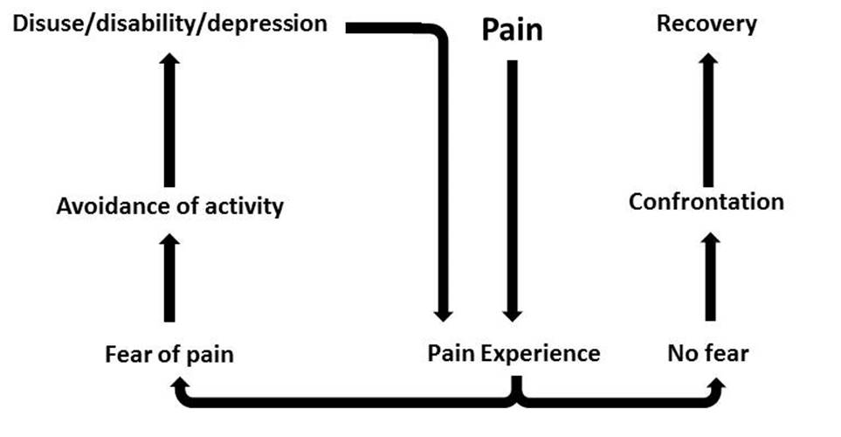
- Chronic pain and anxiety share underlying thought processes and behaviors, such as increased attention to perceived threats and to pain, and anxious avoidance of physical activity. Pain-related fear is sometimes more disabling than pain, itself.
The Fear-Avoidance Cycle, where fear leads us to avoid movement or activities, which leads to deconditioning, increased disability, depression and, ultimately, pain.
Fear of movement
Increased anxiety
- Anxiety and fear avoidance lead to increased disability and poorer quality of life. The diagram, below, shows this ‘fear-avoidance cycle’.
- Anxiety increases pain severity and the likelihood that pain will become chronic.
Why is there a connection between anxiety and pain?
- Some genetic factors contribute to both anxiety and pain
- Some neurotransmitters are involved in both anxiety and chronic pain. For example, lower serotonin or dopamine levels aggravate both.
- Sleep disturbance often present in people with chronic pain leads to increased anxiety and depression.
- People who are anxious tend to misinterpret sensations as harmful or painful
Management of anxiety and pain
- Co-existence of pain and anxiety makes both more difficult to treat.
Increased activity
- Research shows that mindfulness meditation can significantly decrease anxiety, depression, and pain.
- Limit caffeine and alcohol consumption.
- Improve sleep through sleep hygiene, treatment of sleep disorders, or medications
- Physical exercise: aerobic exercise, relaxing forms of exercise, such as qigong, tai chi, yoga.
- Cognitive behavioral therapy (CBT) to address thoughts, feelings and sensations related to both anxiety and pain. CBT can also provide coping skills so people can manage their anxiety and pain, rather than be controlled by them.
- If you cannot find a psychologist to do CBT with you, there are many self-help books available, as well as worksheets available on-line.
- Relaxation techniques such as diaphragmatic breathing, mindfulness meditation, yoga, progressive relaxation.
- Biofeedback can be helpful if you have trouble knowing how to relax. You can now purchase inexpensive sensors that plug into phones or tablet computers.
- Relaxing music. Whatever you prefer, or music designed to calm the nervous system.
- Hypnosis, where people enter a trance-like state and are more open to positive suggestion.
- Aromatherapy (lavender & bergamot were found to be effective).
- Complementary and alternative therapies: acupuncture, qi-gong, yoga, massage, etc.
- Spirituality and religiosity.
On-line resources:
- Anxiety and Depression Association of America at http://www.adaa.org/
- Institute for Chronic Pain (ICP) at http://www.instituteforchronicpain.org. Info on anxiety and pain under Understanding Chronic Pain, Complications.
- A 52-page CBT workbook from England’s National Health Services (excellent resource): http://www.hpft.nhs.uk/_uploads/documents/help-for-adults/cbt-workshop-booklet_web.pdf
- Harvard Health Newsletter: http://www.health.harvard.edu/healthbeat/the-pain-anxiety-depression-connection

Research used in this article:
- Rod K. Observing the effects of mindfulness-based meditation on anxiety and depression in chronic pain patients. Psychiatr Danub. 2015;27(Suppl 1):S209-11.
- Lucchetti G et al. Anxiety and fear-avoidance in musculoskeletal pain. Curr Pain Headache Rep. 2012;16:399-406).
Announcements:
- CLEAR (Center for Lifelong Education and Recreation) at SUNY Potsdam is offering aquatic exercise and Qigong classes, both starting in Feburary. Call 315-267-2167 or go to https://clear.potsdam.edu/wconnect/ace/home.htm and click on Non-Credit Courses.
- Tai chi classes are available through North Country Tai Chi. Find information at www.NorthCountryTaiChi.com, email Sean northcountrytaichi@gmail.com or call
at (315) 229-4003.

Join us on Facebook!
To join the Potsdam Fibromyalgia Support Group on Facebook, contact Kris at: kris.a.lisdesigns37@gmail.com

Tuesday, February 2nd Fibromyalgia Support Group Meeting:
The Potsdam Fibromyalgia Support Group will meet noon-1 pm on Tuesday, February 2nd. The topic is "Anxiety, Stress and Pain.” Anxiety and pain often occur together, each making the other worse. This meeting will be an open discussion of how anxiety affects us and what tools you’ve found that help. A variety of CBT-based hand-outs for anxiety will also be available. Bring any books, CDs, or other resources that you find helpful to show to others. Anyone with a chronic illness is welcome, as are friends and family.

This newsletter is a joint effort of Clarkson University and Canton-Potsdam Hospital. If you would like to receive these newsletters electronically, please send your email address to lrussek@clarkson.edu. You can access current and previous Potsdam Fibromyalgia Support Group Newsletters on our web site: www.people.clarkson.edu/~lnrussek/FMSG.

