Potsdam Fibromyalgia Support Group
Newsletter

October, 2013

Acupuncture for Pain
Although acupuncture is considered ‘alternative’ health care in the West, it is considered ‘traditional’ health care in the East. Acupuncture has been used in China and other Asian countries for more than 3,000 years and was described in one of the first medical texts: Nei Ching, The Yellow Emperor’s Classic of Internal Medicine.
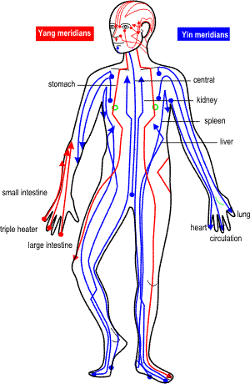
The philosophy of acupuncture is very different from Western medicine. In acupuncture, the practitioner looks for imbalances in Qi, or energy, flowing through the body. Qi can either be blocked, deficient or excessive. Qi flows along meridian lines. Some meridians are Yin (characterized by dark, cold, water) and some are Yang (characterized by light, hot, and fire). Meridians may also be associated with specific organs, such as the liver stomach and heart meridians; this does not mean these meridians control those specific organs, in the Western thinking of things.
Research generally shows that acupuncture is effective in decreasing both acute and chronic pain. For many years, findings suggested that acupuncture was no more effective than strong placebo, or ‘sham’ treatment. In Western scientific thought, a treatment is not considered effective unless it is significantly better than the placebo, or sham treatment. However, more recent systematic reviews of the research conclude that acupuncture is, indeed, more effective than placebo – at least for conditions for which enough research existed: knee pain and chronic headaches. Findings for low back pain and fibromyalgia are not yet clear: acupuncture and sham acupuncture both seem to be about equally effective. This means that acupuncture decreases pain, but a placebo might work equally well.
Meridians
This standard for effectiveness might not make sense for a condition, such as chronic pain, which is a malfunction of the brain’s pain processing system. Whereas acute pain warns the body of impending danger, chronic pain is often not associated with ongoing tissue damage. Chronic pain often occurs because the brain and neural tissues are stuck in the “on” position. The pain is just as real as the pain of burning your finger or stepping on a tack, there just is no burned finger or tack in your foot. Using this concept of chronic pain, a placebo treatment that can change the nervous system from its “on” position is just as effective as any other treatment.
Scientists do not yet fully understand the mechanism by which acupuncture works. In part, it works by activating the body’s endorphin system – the endogenous (made inside your body) opiates. Endorphins are also how the “runner’s high” works. These endorphins, released during acupuncture treatments, decrease pain. Acupuncture also seems to work by decreasing inflammation – both locally, as in an ankle sprain, and also in the neural tissue. Inflammation makes the neural tissue more sensitive, hence amplifies pain. There are a number of other chemical processes that are affected by acupuncture.
Acupuncture also works by altering the ‘default mode network’ in the brain – the mechanism by which our brain keeps track of what is going on in our bodies. Pain, especially chronic pain, disrupts the normal balance in our brain, thereby compromising the brain’s ability to regulate internal experiences such as feelings and emotions.
In summary, acupuncture has strong research for some chronic pain conditions but inconclusive for other conditions. The bottom line, though, is that, each individual person’s response will be different.
Resources used for this article:
- Otti A, Noll-Hussong M. Acupuncture-induced pain relief and the human brain’s Default Mode Network. Forsch. Komplementmed. 2012;19:197-201.
- Hopton A, MacPherson H. Acupuncture for chronic pain: is acupuncture more than an effective placebo? A systematic review of pooled data from meta-analyses. Pain Practice. 2010;10(2):94-102.
- Langhorst J, Klose P, Musial F, et al. Efficacy of acupuncture in fibromyalgia syndrome – a systematic review with a meta-analysis or controlled trials. Rheumatol. 2010;49:778-788.

Melatonin for Migraine
The National Headache Foundation reports a Brazilian researcher found that melatonin, a supplement often used to improve quality of sleep, can help prevent migraines. Some participants took 3 mg. of melatonin at bedtime, while other took amitriptyline (a medication commonly used to prevent headaches and fibromyalgia pain) or a placebo. Headache frequency decreased more in the melatonin group than the amitriptyline group, and much more than the placebo group. Participants taking melatonin also had fewer side effects than the amitriptyline group.
Note that these results have not yet been published, so must be considered preliminary. If you are interested in trying melatonin to combat headaches, talk with your physician to make sure it will not interact with any of your other medications.
Resource for this information:
- http://www.headaches.org/content/news-know-april-2013

Trigger Pointers: Subscapularis
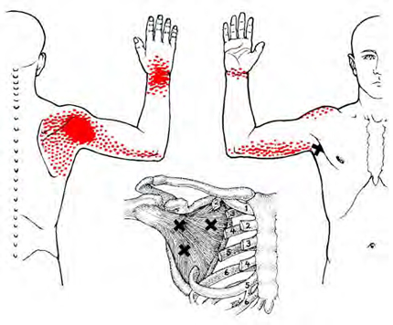
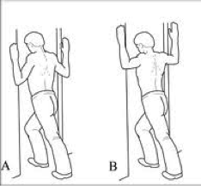
The subscapularis muscle (or “subscap”), as the name suggests, lies underneath the scapula, or shoulder blade. This muscle is one of the rotator cuff muscles: it rotates the arm inward toward your belly. Problems in this muscle can mimic C7 cervical radiculopathy (pinched nerve in the neck), shoulder impingement, thoracic outlet syndrome (pinched nerves between the neck and armpit), and frozen shoulder. Subscap TrP pain is shown in the diagram, below. The pain may be felt deep inside the shoulder.
Subscap TrP will limit your shoulder external rotation (moving your hand away from your belly with your elbow by your side). Other problems that can be caused by subscap TrP include: being unable to lift the arm overhead, unable to reach across the body, ‘frozen shoulder’ or stiffness in multiple directions.
Factors that can lead to subscap TrP include:
- Repetitive movements involving shoulder internal rotation, including swimming, racket or throwing sports,
- Repeatedly lifting objects overhead,
- Prolonged immobilization in a sling,
- Sleeping on that shoulder
- Catching yourself while falling, either by reaching out behind you, or be grabbing onto something with your arm out to the side,
- Shoulder injuries, such as fractures or dislocations,
- Shoulder surgery.
Managing subscapularis TrP: Start by addressing the causative factor, if you are able to identify it. Stretching exercises, shown below, can be helpful, starting with the exercise on the left and progressing to the exercises on the right. TrP release is difficult, because the muscle is not easy to reach; a physical therapist or massage therapist can help.

October Potsdam Support Group Meeting:
The next meeting of the Potsdam Fibromyalgia Support Group will be 6:30 pm on Monday, October 28th. The meeting will be a: Guest presentation by Shelby Connelly, L.Ac, M.Ac., NCCAOM certified acupuncturist: Acupuncture for Managing Fibromyalgia Symptoms. The meeting will be on the 2nd floor of Clarkson Hall.
NOTE: After this meeting, we will switch to “winter hours” of 5 pm (still Mondays). To avoid the November and December holidays, we will have only one Nov/Dec meeting on Monday, December 9th.

This newsletter is a joint effort of Clarkson University and Canton-Potsdam Hospital. If you would prefer to receive these newsletters electronically, please send your email address to lnrussek@clarkson.edu. You can access current and previous Potsdam Fibromyalgia Support Group Newsletters on our web site: www.people.clarkson.edu/~lnrussek/FMSG.

