Potsdam Fibromyalgia Support Group
Newsletter

March, 2011

What Type of Fibro do You Have?
The following discussion is based on the book Fibromyalgia – A Handbook for Self Care and Treatment by Janet Hulme. Ms. Hulme is a physical therapist who specializes in fibromyalgia. The book is based on her decades of practice treating patients with FM, but does not yet have much research support. Ms. Hulme monitored 200 of her patients and found that adding self-care strategies specific to the FM subtype increased tolerance to exercise beyond that with the general self-care strategies.
The premise is that not all FM is the same. Different people have different symptoms and problems, and the FM may have started in different ways. Ms. Hulme describes 5 different types of FM:
- Hypoglycemia or reactive hypoglycemia
  - Shakiness relieved by carbohydrates /sugar or by protein/fat
  - Irritability, irrationality
  - Craves sweets or protein/fat
  - Weakness
- Hypothyroid
  - Cold
  - Weight gain
  - Dry skin
  - Heavy menstrual periods
  - Hair loss
  - Constipation
- Neurally mediated hypotension
  - Dizzy
  - Low blood pressure
  - Increased HR/palpitations
  - Thirsty
  - Abdominal pain

  - Chest pain
- Immune system
  - Recurrent yeast infections
  - Frequent antibiotic use
  - Birth control pill use
  - Frequent cold sores
  - Frequent illnesses
- Reproductive hormones
  - Monthly cycles of FMS pain & fatigue
  - Yearly cycles of FMS pain & fatigue
  - PMS, menstrual pain/irregularity
  - Bowel & bladder irritability
  - Night sweats/hot flashes
The book walks people through a series of tests they can mostly do themselves to figure out which subtype of FM you have. Then the book provides suggestions for stabilizing each of these systems, as well as general guidelines for self-care. Components of the general self-care program include: sleep routine, physiological quieting, nutrition, exercise, medication, positive self-talk, rest/work cycles, pacing/prioritizing, dressing, modalities, journaling.
The Potsdam Support Group has made a bulk order of these books and they will be available to group members for $10 (regular price is $14.95). We will probably use the book to guide some of our upcoming meeting topics. Contact Leslie if you want to get a book: Lnrussek@clarkson.edu or 268-3761 (leave a message).

Trigger Pointers: Pectoralis Major
The past few Trigger Pointers columns have talked about how muscle trigger points relate to visceral problems – that is, problems with your organs. The November newsletter discussed how abdominal muscle TrP interact with the gastrointestinal (GI) system – how TrP can cause GI problems and how GI problems can cause abdominal TrP. The February newsletter discussed how pelvic floor muscles can affect the bowel and bladder. This month: how TrP in the pectoralis major (the “pecs”), the large muscle over the front of the chest, can both look like and trigger heart problems, and how heart problems can provoke pec TrP.
The pecs can refer pain in the chest, shoulder and inner arm (see picture on next page). TrP near the breastbone cause tenderness where the ribs connect to the breastbone, mimicking a condition called costochondritis. Pec TrP are often painful at night and may disrupt sleep. TrP on the left can also provoke a feeling of chest pressure and difficulty breathing, making this TrP look like a heart attack.
These muscles may develop TrP if you:
- Have forward shoulders, a slouched posture or frequently work leaning over a desk or computer,
- Do heavy lifting in front of you or forcefully pull your arm down to your side,
- Store anxiety and tension in your chest.
- Have heart problems, and the heart is referring pain to the pectoral area,
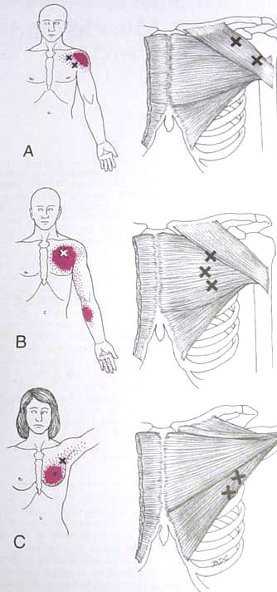
We will look at this last item, the relationship between pec TrP and actual or mimicked heart problems. Travell and Simons, in their book Myofascial Pain and Dysfunction, proposed that TrP could provoke abnormal heart beats in people with healthy hearts. They called the ability for muscles to provoke changes in organ function “somatovisceral” effects [from the Greek root “soma,” referring to the body, and the Latin root “viscera,” referring to ‘internal organs’]. Travell and Simons proposed that pec TrP could provoke rapid or irregular heartbeats and angina, pain from the heart. They also proposed that treating the TrP could relieve angina or irregular heartbeats caused by TrP. Research since then has been inconsistent about whether pec TrP are actually associated with altered cardiac function. The implication is that the benign’ pain or irregular heartbeats associated with TrP can be benign and might not be related to compromised cardiac function.
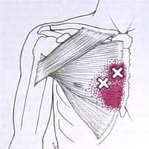
Travell and Simons also proposed “viscerosomatic” effects, where heart disease can provoke pec TrP. They found a higher prevalence of left-sided pec TrP in people who had known heart disease. The lesson here is that finding TrP in the pecs on only the left side could be an indication that you have heart disease.
In summary, pec TrP can look like a number of benign to serious medical problems. It may be wise to have your doctor rule out these problems if you have left-sided chest and arm pain so you are reassured that your pain is just due to TrP.

Signs of Heart Attack in Women
While we are on the topic of heart problems, women should be aware that they often present with different signs of heart attack than men. While men typically present with left sided chest and arm pain, only 30% of women experience chest pain during a heart attack. Instead, symptoms typically experienced by women are:
Women’s symptoms before a heart attack:
- Unusual fatigue (70%)
- Sleep disturbance (48%)
- Shortness of breath (42%)
- Indigestions (39%)
- Anxiety (35%)
Women’s symptoms during a heart attack:
- Shortness of breath (58%)

- Weakness (55%)

- Unusual fatigue (43%)
- Cold sweat (39%)
- Dizziness (39)
Unfortunately for people with FM, all of these are commen FM symptoms. If you experience a sudden change in these symptoms, though, consider the possibility of having a heart attack.

Help PT Students Learn About FMS
Each year, Clarkson Physical Therapy graduate students learn about fibromyalgia by meeting with volunteers who have FM. This year I am looking for 6-7 people with FMS to come in Friday, April 22nd, 10:30-noon. It involves about 60 minutes of talking with 2-3 students and about 30 minutes of allowing them to do a few tests that a PT might do on an initial visit (you do only what you are comfortable doing). If you are available and willing to help, please contact Leslie at 268-3761 or Lnrussek@clarkson.edu. Help make the next generation of health care providers more aware of and sensitive to FMS!

March 28th Potsdam Meeting:
The Potsdam Fibromyalgia Support Group meeting, Monday, February 28th, 5:30 will be: The 5 subtypes of fibromyalgia: hypoglycemic, hypothyroid, neural hypotension, immune system, and hormonal: what type are you? Meetings will still be in Clarkson Hall, at 59 Main St. Although the CPH Physical Therapy department has moved, the Fibromyalgia Support Group remains in its previous location. For information about meetings, contact CPH Physical Therapy Department at 261-5460.

Massena Meetings Have Started Again!!!!
The Massena Support Group is meeting again at 1:30 pm on the 2nd Saturday of each month in the Massena Hospital, (ask for room location at the front desk). The April 9th meeting is on “Common Sense and Positive Thinking.” For more information, please contact facilitator Maxine Dodge, at 769-5778.

This newsletter is a joint effort of Clarkson University and Canton-Potsdam Hospital. If you would prefer to receive these newsletters electronically, please send your email address to gilberta@clarkson.edu. You can access current and previous Potsdam Fibromyalgia Support Group Newsletters on our web site: www.people.clarkson.edu/~lnrussek/FMSG.

