Potsdam Fibromyalgia Support Group
Newsletter

August, 2007

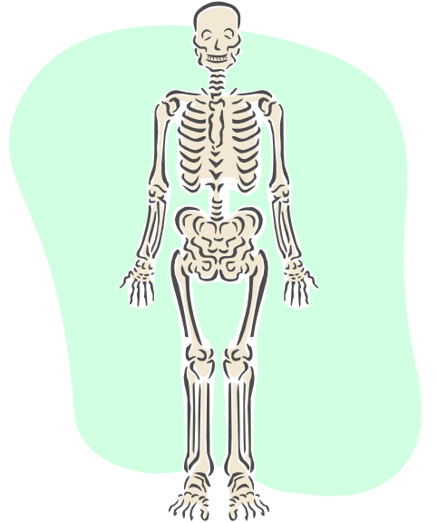
Osteoporosis

10 million people in the US have osteoporosis and 34 million more have osteopenia, which is bone density that is low, but not as low as osteoporosis. 80% of those with osteoporosis are women. Some osteoporosis facts from the National Osteoporosis Foundation (NOF) web page (http://www.nof.org/osteoporosis/diseasefacts.htm).
One in two women and one in four men over age 50 will have an osteoporosis-related fracture in her/his remaining lifetime.
Osteoporosis is responsible for more than 1.5 million fractures annually, including:
- over 300,000 hip fractures; and approximately
- 700,000 vertebral fractures;
- 250,000 wrist fractures; and
- 300,000 fractures at other sites
Some of the risk factors include:
- Being female
- Being thin and/or having a small frame
- Advanced age
- A family history of osteoporosis
- Estrogen deficiency as a result of menopause, especially early or surgically induced
- Abnormal absence of menstrual periods (amenorrhea)
- Eating disorders (such as anorexia nervosa)
- Low lifetime calcium intake
- Vitamin D deficiency (includes lack of sunlight)
- Use of certain medications (antiseizure medicines are most likely with FMS, but also corticosteroids, chemotherapy, and others)
- An inactive lifestyle
- Cigarette smoking or excessive use of alcohol
- Being Caucasian or Asian, although African Americans and Hispanic Americans are at significant risk as well

While the definitive test for osteoporosis is a dualenergy x-ray absorptiomerty (DXA or DEXA),” there are simple screening tests to learn if you are at risk and have the DXA test done. One easy and accurate screening tool is caused the Osteoporosis Self-Assessment Screening Tool (OST). You can calculate it yourself as:
[(weight in kilograms - age in years) x 0.2],
Or use an on-line osteoporosis risk calculator at: http://www.hpb.gov.sg/hpb/default.asp?pg_id=1731.
If your score is below 0, your risk of having osteoporosis is only 3%. If your score is between 0 and 20, you have a 17% risk. If your score is above 20, you have a 61% risk of having osteoporosis.
Even if you don’t have osteoporosis now, what you do now affects the chance that you may develop osteoporosis later in life. If you don’t develop the proper bone density when you are young, and maintain it in your mid-adult years, then you will be starting from a lower level when you begin to lose bone faster as you get older.
The NOF has 5 suggestions for preventing osteoporosis:
- Get your daily recommended amounts of calcium and vitamin D
- Engage in regular weight-bearing exercise
- Avoid smoking and excessive alcohol
- Talk to your healthcare provider about bone health
- When appropriate, have a bone density test and take medication
At this month’s meeting in Potsdam, Leslie will present information about exercises that even someone with FMS can do to prevent or slow down osteoporosis.

Music to Soothe the FMS Beast

The July issue of Fibromyalgia Network has a short article on using music to ‘transform’ your pain. The author found that wearing one of the portable music players (like an i-Pod) allowed her to play upbeat music that helped her keep moving. Music with a beat encourages you to bob, sway, wriggle or shuffle. It can also distract your mind from the constant pain of FMS.
Research supports the idea of using music to manage chronic pain. The June 2006 issue of Journal of Advanced Nursing reported a study with 3 groups of subjects with chronic pain: those who listened to self-selected music, those who listened to relaxing music selected for them, and those who did not listen to music. Results showed both groups who listened to music reported improvements:
- 12-21% less pain than before the study
- 19-25% less depression than the control group
- Feeling 18% less disabled than the control group
- Feeling more control over their pain than the control group.
So, maybe it’s time to get some music into your life. Get a beat rather than feeling beat!
Source: Siedlecki, Sandra L. and Good, Marion. “Effect of music on power, pain, depression and disability.” Journal of Advanced Nursing. Vol. 54.5. June, 2006: 553-562.
Trigger Pointers
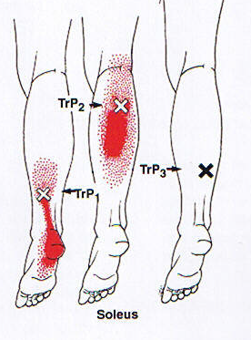
We are going to try a new ‘column’ in the newsletter – a description of common trigger points and stretches you can do to eliminate them. We’ll start from the ground with the gastrocnemius and soleus muscles, the two big calf muscles. These muscles are likely to develop trigger points (TrP) with a lot of walking or if the muscles are tight. Sometimes they get tight overnight (because your ankles often straighten, allowing the muscles to shorten), and cause morning foot or heel pain that resembles plantar fasciitis.
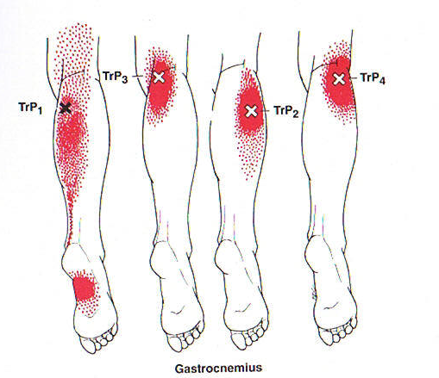
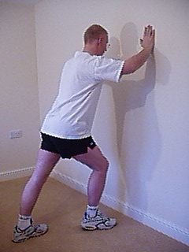

To manage these trigger points, avoid shoes with high heels, and stretch the muscles regularly, especially before and after walking. If your pain is worse first thing in the morning, try to position your ankles so that they stay near a 90° angle overnight (you may need to prop the sheets so they don’t pull your feet down). A good stretch for these muscles is shown at the left. Keep your back knee straight for the gastroc stretch (feel stretch at top of calf) and bend the back knee for soleus stretch (feel stretch at bottom of calf).


Fibromyalgia Limerick Contest:
In our discussion of ideas for our North Country FMS booklet, we thought it might be fun to have an FMS limerick contest. To get us started (and show that talent and quality aren’t necessary to have fun):
There once was a woman in pain
Who thought she had nothing to gain
By trying to write
But she wasn’t right,
Now writing’s what’s keeping her sane.
So, send in your limericks – silly, sad, or sappy!

How To Say “I’m not feeling well”
The July issue of Fibromyalgia Network also listed several humorous ways to say you aren’t having a good day. Here are a couple of theirs and a few more:
- “The alien is back.”
- “I’m having a zombie day.”
- “My get up and go has got up and went.”
- “The tiger isn’t in my tank, today,”
- “I’m fi-broken today.”
What is your favorite way to describe a bad FMS day? Send it in or share at a meeting and we’ll add to our list.

July Potsdam Meeting:
The Potsdam Fibromyalgia Support Group March meeting will be Thursday, July 23rd 4:30 pm. The topic will be: “Osteoporosis: Risk, management and prevention.” Even if you don’t have osteoporosis now, what you do now will affect your bones 10 years from now. The meeting is in Clarkson Hall at 59 Main St. For more info, contact Canton-Potsdam Hospital Physical Therapy Department at 261-5460 or email Lnrussek@clarkson.edu. Note the special 4:30 time for this meeting.

August Massena Meeting:
The Massena Fibromyalgia Support Group will meet at Massena Memorial Hospital Tuesday, September 11th at 6:30 pm. The discussion topic will be: “Dealing with the changing seasons” For more information, contact facilitator Maxine Dodge, at 769-5778 or maxinesbeach@wmconnect.com.

This newsletter is a joint effort of Clarkson University and Canton-Potsdam Hospital. If you would prefer to receive these newsletters electronically, please send your email address to gilberta@clarkson.edu. You can access current and previous Potsdam Fibromyalgia Support Group Newsletters on our web site: www.people.clarkson.edu/~lnrussek/FMSG.

