Potsdam Fibromyalgia Support Group
Newsletter

May-June, 2007

Gardening Made Easy
It’s the time of year when everything is growing. You love to garden, but your body can’t do what it used to. Rather than give up gardening, adapt how you garden.
- Use carts and wheelbarrows to carry your tools, soil, or plants. Don’t carry things further than you need to.
- Bring the garden to you: use raised beds so you don’t have to lean over to plant or weed. You can even make the top of the bed wide enough to sit on, so you can sit while you weed.
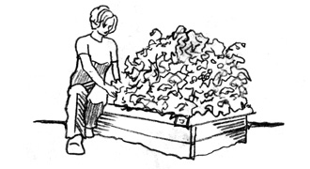
(Line drawings in this newsletter are from the Virginia Cooperative Extension, at http://www.ext.vt.edu)
- Change positions frequently – at least every 10-20 minutes. If you have been leaning forward, stretch by leaning backwards. If you have been kneeling for a while, switch to standing. If you lose track of time set a kitchen timer to remind you to get up and stretch.
- Do more container and hanging gardens – they are easy to reach and simpler to weed. You can even grow tomatoes and strawberries in hanging gardens.
- Delegate! Decide what needs to be done and what you most enjoy doing. Delegate or hire someone to do the difficult work and save your energy for what you enjoy most.
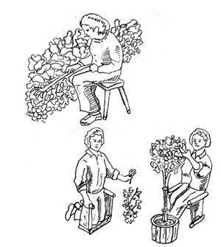
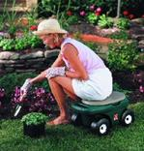
- Get a kneeling stool or a rolling scooter stool. The kneeling stools allow you to kneel on them in one orientation and sit on them if you flip them over. The scooter stools are like benches on wheels, allowing you to move down a flower bed without getting up and down so often.
- Think of gardening as a sport: warm up with a short walk and do stretches before and after you garden; this will decrease stiffness later.
- Use mulch so you don’t need to weed as much. Put 3-4 layers of newspaper under the mulch to minimize weeds even more.
- Do a little at a time. This means lift only a little dirt on the shovel, weed only a little of your flower bed, plant only a few plants, or carry only a little bit at a time.
- Use good posture: walk and sit up right whenever you can. Avoid leaning, slouching and twisting movements. Lift from your knees rather than your waist. Keep your wrists straight.
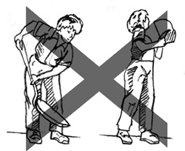
- Get the right tool. Long-handled tools allow you to work from standing rather than bending over. While you can buy ergonomic gardening tools (see sources at the end of this article), you can also adapt existing tools. Bicycle handle-bar grips make handles fatter and softer to grip. PVC piping can make a short handled tool into a long-handled tool. You can buy handles to attach to existing tools to improve leverage. Select tools that are lightweight and sharp.
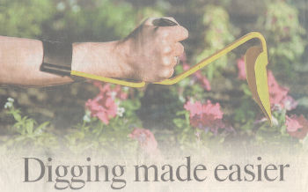
Ergonomically designed gardening tools, by companies such as Earth Bud-Eze Hand Tools, available on line at places such as Amazon.com.

Other companies that sell ergonomically designed gardening tools:
- http://www.lifewithease.com/garden.html
- www.garden.com
- www.activeforever.com (which also has an informative article “Gardening Without Pain”)

More ideas are available at:

“Gardening and Your Health: Protecting Your Knees and Back” from the Virginia Extension Cooperative (http://www.ext.vt.edu)
- “Gardening Without Pain” at www.activeforever.com


Most of all, remember to stop working long enough to sit and enjoy your garden!
Summer Exercise Tip:
Summer is for swimming, and water is a great way to get exercise that won’t stress your body as much as land exercise. General guidelines: Move slowly using a count of 4 for each motion. Tighten your abdominal muscles to provide core stability. Start gradually, so you aren’t too fatigued when you get out of the water. Some exercise ideas:
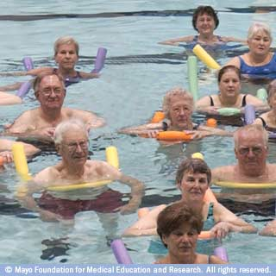
- Walking in water: you can walk forwards, backwards, and sideways, or even just march in place.
- Upright bicycle: hold a noodle or float under your arms and bicycle with your legs.
- Push-ups from the side of the pool.
- Leg lifts or arm swings in different directions.
Picture from mayoclinic.com

June Potsdam Meeting:
The Potsdam Fibromyalgia Support Group March meeting will be Thursday, June 28th 6:30 pm. The topic will be: “If you could write a book about your experiences with fibromyalgia, what would it say?” Some Support Group members are thinking about compiling a book of writings from North Country people with FMS. What does FMS mean to you? What do you want people to know? The meeting is in Clarkson Hall at 59 Main St. For more info, contact Canton-Potsdam Hospital Physical Therapy Department at 261-5460 or email Lnrussek@clarkson.edu.

July Massena Meeting:
The Massena Fibromyalgia Support Group will meet at Massena Memorial Hospital Tuesday, July10th at 6:30 pm. The discussion topic will be: “Pacing ourselves in the summer heat, cooling down without causing fibro flare-ups (e.g., using AC and swimming in cold water)” For more information, contact facilitator Maxine Dodge, at 769-5778 or maxinesbeach@wmconnect.com. Note that the Massena meeting is returning to its normal 2nd Tuesday evening time.

This newsletter is a joint effort of Clarkson University and Canton-Potsdam Hospital. If you would prefer to receive these newsletters electronically, please send your email address to gilberta@clarkson.edu. You can access current and previous Potsdam Fibromyalgia Support Group Newsletters on our web site: www.people.clarkson.edu/~lnrussek/FMSG.


