Core Strengthening
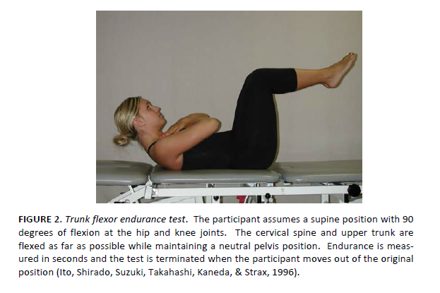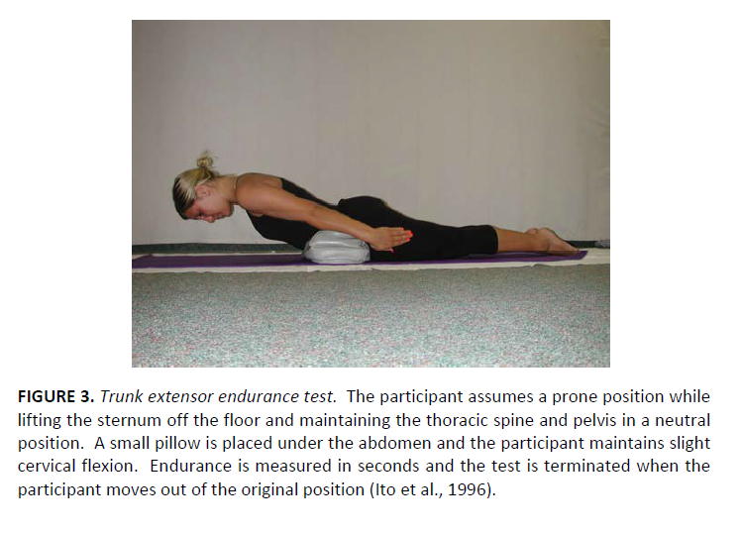
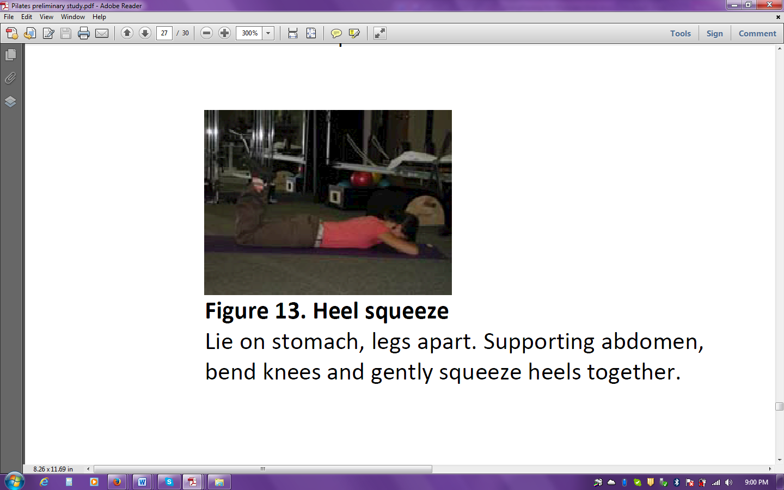
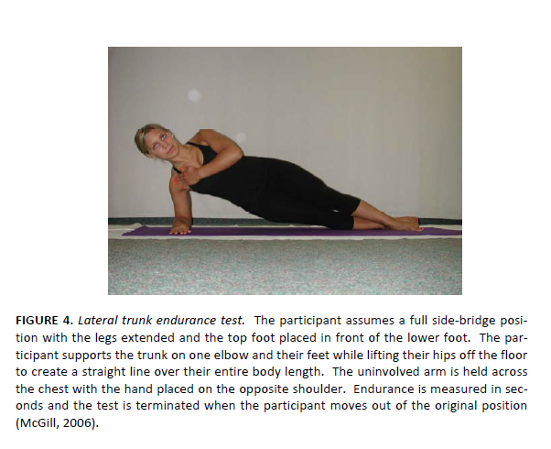
Shoulder Strengthening

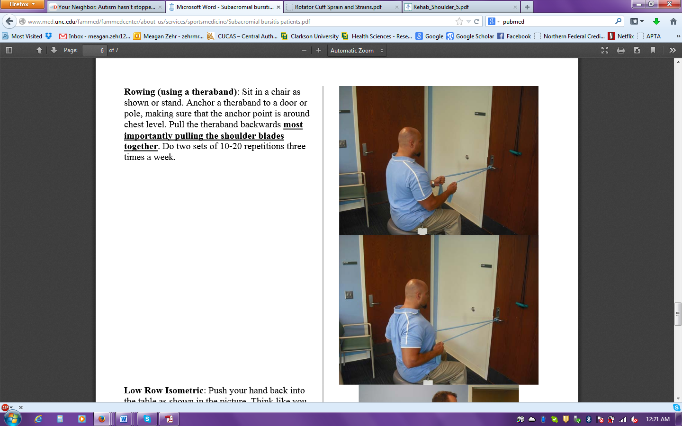
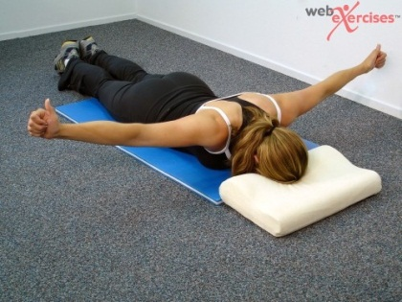

Laying facedown on the floor bring your arms out to the side in a T shape with your thumbs pointed to the ceiling. When lifting the arms up as high as they will go while keeping the shoulders from shrugging up toward the head.
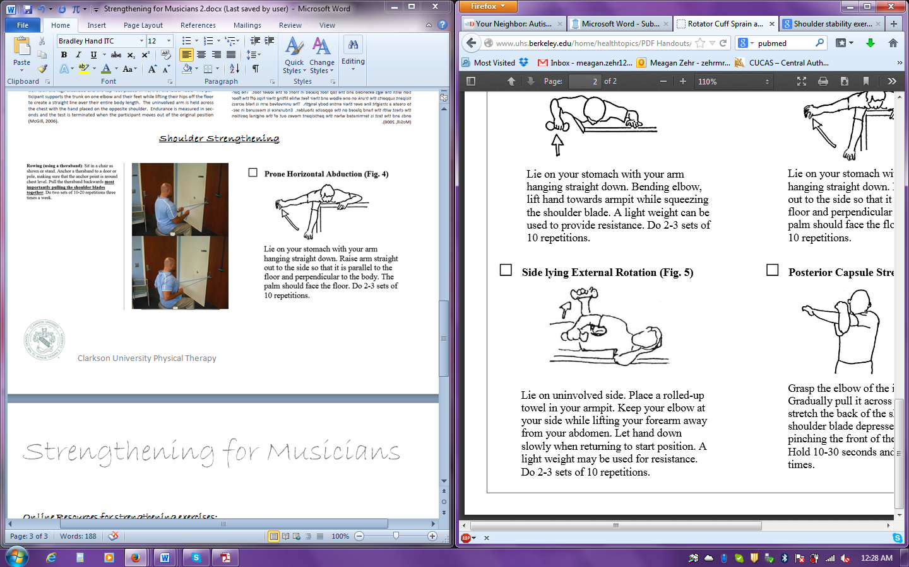
Exercise with Weights
Strengthening:
You want to use a
Heavier weights and fewer
Repetitions. You want to use a
Weight that will allow you to do
between 4-6 repetitions

Endurance:
You want to use a lighter weight
with more repetitions. You want
to use weights that will allow you
to do between 12-15 repetitions

Online Resources for strengthening exercises:
- Exercises for the Rotator Cuff and a comprehensive Shoulder conditioning program: http://orthoinfo.aaos.org/PDFs/Rehab_Shoulder_5.pdf
- Palates exercise program and weight program for the whole body:
Kava KS, Larson CA, Stiller CH, Maher SF. Trunk endurance exercises and the effect on instrumental performance: a preliminary Study comparing Pilates exercise and a trunk and proximal upper extremity endurance exercise program. Music and Health. 2012;3(1):1-30.
- Basic information for the Rotator cuff with comprehensive shoulder program: http://www.uhs.berkeley.edu/home/healthtopics/PDF%20Handouts/Rotator%20Cuff%20Sprain%20and%20Strains.pdf
- Basic information for Subacromial Bursitis with comprehensive stretching and strengthening program: http://www.med.unc.edu/fammed/fammedcenter/about-us/services/sportsmedicine/Subacromial%20bursitis%20patients.pdf

Apps on iPhones and iPads for Exercise:
- Nike Training – free app: provides exercise programs for specific areas of the body
- iMuscles 2 - $4.99: provides individual exercises for whole body with/without the use of equipment

