Potsdam Fibromyalgia Support Group
Newsletter

September, 2015

Aromatherapy
Aromatherapy, or using scent to evoke a psychological or physiological response, has become popular, especially among people trying to avoid side effects associated with many medications. Aromatherapy uses essential oils from plants, seeds, bark and flowers. In fact, a scent is not technically required, as chemical compounds that are not aromatic can also have psychological or physiological effects, so the terms ‘essential oil therapy’ or, more technically ‘phyto-essential pharmacology’ may be more accurate.(Perry & Perry, 2006) But, for the purposes of the current discussion, we will refer to these airborne chemicals as scents.
Aromatic oils have been used for thousands of years, in ancient Egypt, China, India and Greece. The bible even has almost 200 references to aromatics used for mental, spiritual or physical healing. (Perry & Perry, 2006)
The scent can be inhaled, either by smelling it in the bottle, spraying it in the air, or diffusing it by burning a candle, incense or aromatherapy oil burner. Essential oils can sometimes also be applied to the skin, typically diluted in another oil or in bath water. Pure essential oils often should not be applied directly to the skin as they can irritate the skin. Oils applied to the skin may work through inhaling the volatile oils or through direct absorption through the skin. Essential oils for aromatherapy should never be taken internally.
The mechanism for aromatherapy is not fully understood. In part, the scents seem to stimulate olfactory nerves, which connect directly to the limbic system in the brain, which explains why aromas can have an immediate effect. (U MD web site) The limbic system regulates mood and the suffering components associated with chronic pain. Aromatherapy appears to work by stimulating release of serotonin and dopamine in the brain. (Lv et al, 2013)
Research suggests that aromatherapy may help decrease stress, anxiety, depression, and insomnia. (Lee, et al, 2012; Perry & Perry, 2006) Direct evidence for decreasing pain is mixed but, since chronic pain is aggravated by stress, anxiety, etc., aromatherapy may have secondary benefits for pain. Although the research is not strong, aromatherapy has few adverse effects (if used properly) and may provide a helpful adjunct to pain management.
Specific response to scents can be very individual – especially if you have memories associated with certain smells. However, certain essential oils tend to be most effective for specific symptoms. The chart on the back page is a very comprehensive list from Perry and Perry (2006). The University of Maryland Medical Center web site has reliable general information about aromatherapy.
Resources used:
- Lee MS, Choi J, Posadzki P, Ernst E. Aromatherapy for health care: an overview of systematic reviews. Maturitas. 2012;71:257-260.
- Lv XN, et al. Aromatherapy and the central nerve system (CNS): therapeutic mechanism and its associated genes. Curr Drug Targets. 2013;14(8):872-9.
- Perry N, Perry E. Aromatherapy in the management of psychiatric disorders: clinical and neuropharmacological perspectives. CNS Drugs. 2006;20(4):257-280.
- University of Maryland Medical Center web site at: https://umm.edu/health/medical/altmed/treatment/aromatherapy.

September 14th Support Group Meeting:
The Potsdam Fibromyalgia Support Group will meet on Monday, September 14th at 7 pm. The topic will be “Making Sense of Scents: Aromatherapy.” People can share their experiences with aromatherapy and what scents work for you. Bring your favorite scent to ‘show’ others. NOTE: For those who tend to have adverse reactions to smells, this might be a session to skip.

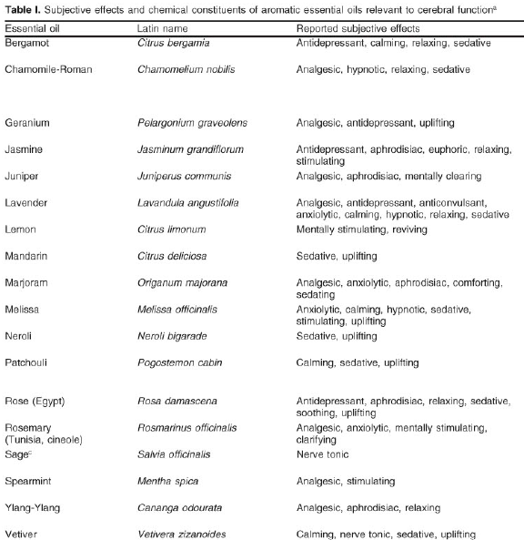
(Chart from Perry & Perry, 2006)

This newsletter is a joint effort of Clarkson University and Canton-Potsdam Hospital. If you would prefer to receive these newsletters electronically, please send your email address to lnrussek@clarkson.edu. You can access current and previous Potsdam Fibromyalgia Support Group Newsletters on our web site: www.people.clarkson.edu/~lnrussek/FMSG.

