Potsdam Fibromyalgia Support Group
Newsletter

November-December, 2008

In the News:
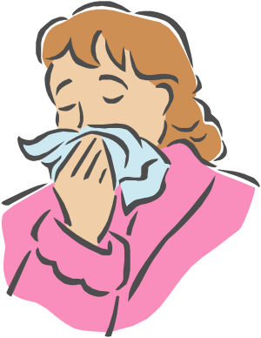
Sinusitis: Sinusitis, or sinus infection, may be related to aches and pains all over the body. Medical researchers performed a meta-analysis (analyzing many other research articles to see what conclusion all the research comes to) looking at the relationship between bodily pain and sinusitis. They found that people with sinus problems were more likely to have generalized body pain than people without sinus problems. In fact, pain levels in one study, where the average age was 43, was closer to pain levels observed in people over 75. Pain levels to people with diffuse osteoarthritis. (This was presented in a lecture titled “Effect of Sinus Surgery on Bodily Pain: A Meta-analysis”)
Studies have also linked sinusitis to severe fatigue (Am J Med. 2008 Oct;121(10):e13) and yet another study showed that sinus surgery significantly reduced fatigue, including in patients with FMS (Am J Rhinol. 2008 Jul-Aug;22(4):420-6).
All together, this line of research suggests that sinusitis may cause symptoms similar to some symptoms patients with FMS experience. If you have sinus problems that you have been ignoring because you thought they were less important than the pain and fatigue of FMS… consider talking to your doctor about it.

New FMS medication close to market: The FDA is in the final stages of reviewing a new medication proposed for management of FMS: Milnacipran, from Cypress Bioscience. The medication works by changing metabolism and uptake of norepinephrine and serotonin, two neurotransmitters thought to be involved in regulating both pain and depression. Phase III trials have shown that people with FMS who took Milnacipran showed improvements in pain, function, and quality of life for up to a year. Current research is looking at side effects, since people with FMS often have trouble taking medications. For more information about the medication (note that this information is from the manufacturer, so the view may be biased towards the positive): http://www.cypressbio.com/products/milnacipranPhase3.php . The FDA is scheduled to complete review of Milnacipran by the end of 2008.

The Gift of Knowledge:

For the holidays, consider getting yourself a book that can help you manage your FMS. Some suggestions:
- Taking Charge of Fibromyalgia by Julie Kellie and Rosalie Devonshire. Comprehensive self-management strategies. The Support Group still has discounted copies of this available for $15 (it is normally $25); contact Leslie for a copy.
- Fibromyalgia and Chronic Myofascial Pain Syndrome: A Survival Manual by Devin Starlanyl and Mary Ellen Copeland. Available on their web site, or by special order from bookstores.
- The Fibromyalgia Advocate: Getting the Support You Need to Cope with Fibromyalgia and Myofascial Pain Syndrome also by Devin Starlanyl and Mary Ellen Copeland. This can help you advocate for your health care.
- Fibromyalgia for Dummies by Roland Staud and Christine Adamec. Light-hearted approach is particularly helpful for getting family and friends to read.
- Your Personal Guide to Living Well with Fibromyalgia, by the Arthritis Foundation. Work-book format to help you learn self-help strategies. Available one their web site.
- The Pain Survival Guide: How to Reclaim Your Life by Dennis W. Turk, PhD and Frits Winter, PhD. Good explanation of chronic pain. Describes 10 practical steps to regaining control over your life in spite of pain.


- Managing Pain Before It Manages You, by Margaret A. Caudill-Slosberg provides clear explanations of pain, how it affects us, and a workbook format for learning to manage your own pain.
- The Relaxation & Stress Reduction Workbook by Martha Davis, Matthew McKay, and Elizabeth Robbins Eshelman. Excellent guide to a variety of strategies and techniques for managing stress, an important part of chronic pain management.
Trigger Pointers: Facial Muscles
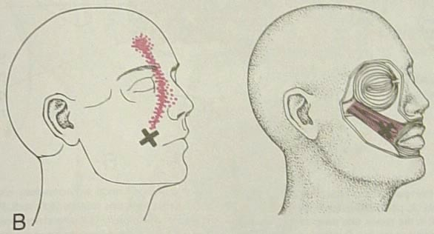
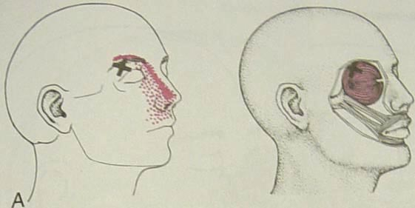
Trigger points (TrP) in facial muscles can cause pain and symptoms that may feel like sinus headaches. The zygomaticus muscle goes from the mouth to the side of the cheek and helps with facial expression, such as smiling. TrP in the zygomaticus can result in a runny nose, sneezing and itchy eyes that might appear to be allergy or sinus problems. The orbicularis oculi muscle goes around the eye and allows you to squeeze your eye shut. A TrP in this muscle can make it difficult to read due to the print seeming to jump around on the page; it can also cause twitching of the eye or drooping eyelid.
Zygomaticus
Orbicularis oculi
Trigger points in the orbicularis oculi may develop as secondary TrP from the sternocleidomastoid (SCM), or through frequent frowning, squinting, eyestrain, or tension. The zygomaticus TrP can be caused by temporomandibular joint problems that restrict mouth opening. If these muscles develop TrP because you already have a headache or sinus pain, they can perpetuate your these problems, making them difficult to treat. It is important to note that sinus symptoms due to TrP might not respond to sinus medication.
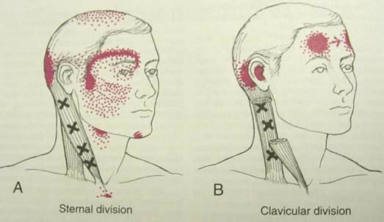
Other muscles that can contribute to facial pain:
- The SCM can cause pain and symptoms in a variety of locations on the face and head. The SCM causes a lot of non-pain symptoms such as blurry vision, dizziness, sinus pain and drainage, ringing in the ear and droopy eyelid. See the October, 2007 newsletter for info on the SCM)
Sternocleidomastoid
- The platysma, a large sheet muscle going from the chin to the collar bone. This muscle causes pain and prickliness over the cheek and chin.

- The temporalis, which causes pain over the forehead, jaw and teeth (see the May, 2008 Newsletter)

- The pterygoid muscles that work the jaw will cause jaw and cheek pain.
So, what can you do about TrP in the facial muscles? First, look for and work on TrP in other muscles, such as the SCM. If the facial muscle TrP are secondary TrP, you have to address the primary muscles first. You cannot really do stretch exercises for the facial muscles as these muscles attach to the skin rather than to bones and joints. However, massaging around the eyes and cheeks can stretch facial muscles and relieve TrP.
Try to decrease the amount of tension you store in your face; notice if you tend to frown, squint or grimace. If you store tension in your face muscles, try relaxation exercises such as diaphragmatic breathing or progressive relaxation. One progressive relaxation exercise you can do is tense up the muscles in your face by squeezing your eyes shut, clenching your teeth, and grimacing while you inhale, then let go and relax these muscles as you exhale. Sometimes feeling the difference between when the muscles are tense and relaxed helps you to recognize when you do store tension in these muscles.


December Potsdam Meeting:
The Potsdam Fibromyalgia Support Group December meeting will be Thursday, December 11th 5-6 pm (shifting to our winter hours so people don’t have to be out so late). Topic: Holiday Social and open discussion.For more info, contact Canton-Potsdam Hospital Physical Therapy Department at 261-5460 or email Lnrussek@clarkson.edu.

December Massena Meeting
The Massena Fibromyalgia Support Group will meet Saturday, December 13th at 1:30 in Massena Memorial Hospital. Theo topic will be “Coping with the Change of Seasons.” For more information, contact facilitator Maxine Dodge, at 769-5778 or maxinesbeach@wmconnect.com. Note the change in both time and day!

This newsletter is a joint effort of Clarkson University and Canton-Potsdam Hospital. If you would prefer to receive these newsletters electronically, please send your email address to gilberta@clarkson.edu. You can access current and previous Potsdam Fibromyalgia Support Group Newsletters on our web site: www.people.clarkson.edu/~lnrussek/FMSG.

