Potsdam Fibromyalgia Support Group
Newsletter

June, 2013

Acupressure
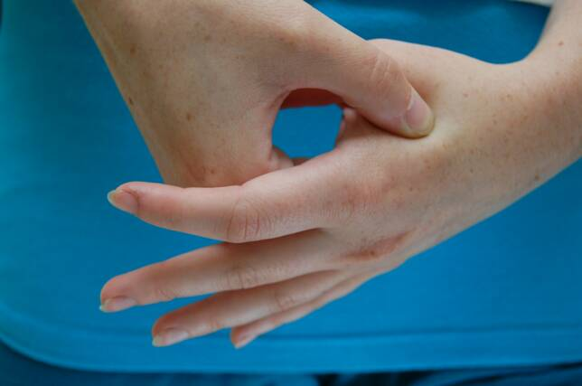
Acupressure is a form of Traditional Chinese Medicine (TCM) that uses pressure on specific acupuncture/acupressure points. The points are on the yin and yang meridians, or energy pathways, used in Chinese medicine. The 12 standard meridians are each associated with a vital organ such as the lung, heart, gall bladder, etc.; 8 other meridians are considered energy storage vessels. In Chinese medicine, illness occurs when the energy along these pathways is either blocked or excessive. Treatments such as acupuncture and acupressure are believed to work by stimulating the flow of energy along these meridians.
Acupressure can be applied by pressing or rubbing with a finger, small ball, roller or various knobby devices. Special purpose devices also exist, such as the wrist strap that presses on a point called ‘nei-kuan’ on the inside of the wrist. You can have someone do acupressure to you or apply it to yourself. Pressure can be applied for 1-3 minutes or, using a strap (as for nausea), can be applied 24 hrs a day. Start with light pressure and increase the pressure as it becomes more comfortable. Change the angle of your pressure until you feel optimal effect. You may feel a light aching or tingling when you press the correct location; it should never be uncomfortably painful.
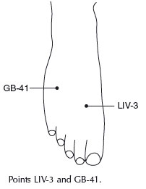
Acupressure points are located using body landmarks and the length of your middle finger bone, called a ‘cun.’ Some points are muscle trigger points while others are quite different. Sources of information about acupressure are listed at the end of this article.
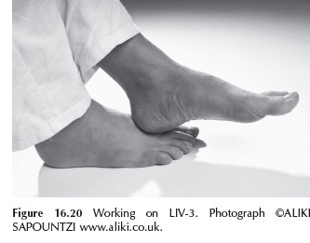
Scientific research into the effectiveness of acupressure is not definitive and we have no anatomic explanation for how it might work. However, research suggests that acupressure is useful for at least some conditions. Conditions that appear to benefit from acupressure (and the strength of research evidence) include:
- Menstrual pain (strong)
- Low back pain (strong)
- Headaches (moderately strong)
- Nausea (moderately strong)
- Depression (moderate)
- Anxiety & stress (variable)
- Insomnia and fatigue (variable)
In spite of some positive research findings, the consensus is that more research is still needed. However, acupressure is inexpensive, can generally be applied to oneself anywhere or any time, and has virtually no adverse effects (see list below of people who should be cautious using acupressure). People with fibromyalgia pain and symptoms might want to explore acupressure as a component to their self-management program.
Deep pressure such as acupressure should be avoided or used cautiously in areas affected by cancer, rheumatoid arthritis, bone weakness or injury, blood-thinning medication, and varicose veins; pregnant women should be cautious because some acupressure points (just like massage in some areas) can stimulate contractions.
LI-4
Headache: The diagrams in this newsletter show 3 of the 8 acupressure points for headache; treat both sides. LI-4, one of the best-known acupressure points, lies in the web-space between your thumb and index finger, towards the base of the index finger; press until you feel a dull ache in the muscle.
You can stimulate LIV-3 and GB-41 using the heel of your opposite foot. For LIV-3, place your left heel on top of your right foot between the 1st and 2nd toe for 1 minute. You can press or rub this area gently. To stimulate GB-41, place your heel between your 4th and 5th toe and work as above. Repeat on the other foot
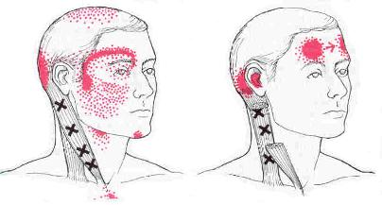
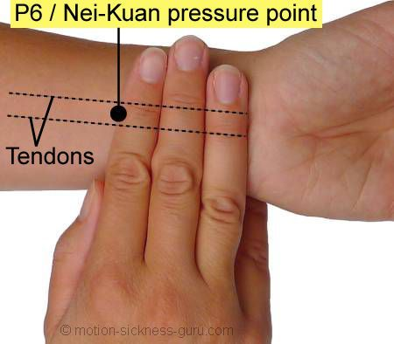
Nausea: P6, the nei-kuan point, is 3 finger widths above the front wrist crease, can decrease nausea and motion sickness (this is the point stimulated in sea-sickness wrist bands). Shown below and left.
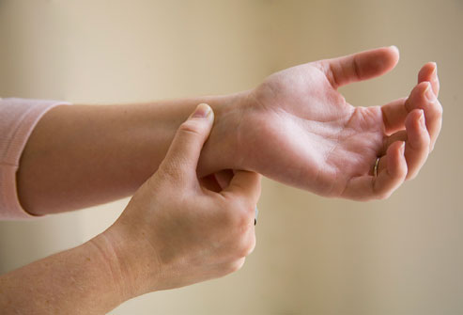

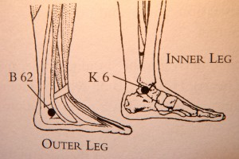
Insomnia: A pair of points for insomnia is shown below. The point, K6, on the inside of the ankle is called Joyful Sleep and B62, on the outside of the ankle, is called Calm Sleep. Press on these points while doing deep breathing for several minutes before bed-time. You can press both points by using your thumb on one side and fingertips on the other.

Resources for self-treatment include:
- Acupressure Potent Points by Gach (also has an informative blog: www.acupressure.com/blog)
- Acupressure and Reflexology for Dummies by Dempsey & Andrews.
- A web site DIYacu http://www.diyacu.com/
- An iPhone/iPad app called ‘Acupressure: Heal Yourself’.

Scientific sources used in this article:
- Robinson N, Lorenc A, Liao X. The evidence for Shiatsu: a systematic review of Shiatsu and acupressure. BMC Comp Alt Med. 2011;11:88.
- Lee EJ, Frazier S. The efficacy of acupressure for symptoms management: A systematic review. J Pain Symptom Manage. 2011;42(4):589-603.
- Chen YW, Wang H-H. The effectiveness of acupressure on relieving pain: a systematic review. Pain Manag Nurs. 2013;e-pub Feb 15.

Trigger Pointers: SCM

The sternocleidomastoid (SCM) is a common source of migraine-like headaches. Pain, as shown below, can be over the forehead, cheeks, back of head and ear.

Other symptoms: Ear ache, ear fullness, ringing in the ear; dizziness and balance problems; blurred vision; sinus pain or congestion on one or both sides; tearing or redness of one eye or drooping of one eyelid; sore throat or dry cough; nausea

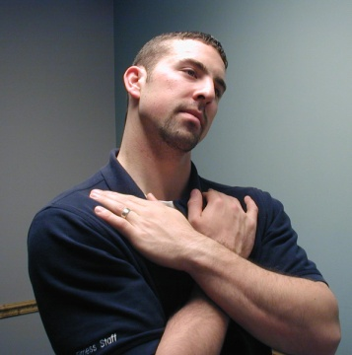
Aggravating factors: forward head posture (chin poking forward); rounded shoulders or tight pectoral muscles; sitting with head turned to the side (e.g., watching TV or at a computer workstation); sleeping on the back with extra pillows that tilt head forward; prolonged tilting head backward (e.g., with overhead work or front-row theater seats); whiplash-type injury; holding the phone between your shoulder & ear; using neck muscles for breathing, especially after a chronic cough or asthma.
To stretch the SCM: sit up straight and place both hands on your chest, pressing downward toward your stomach. Gently bend your ear toward your shoulder and then extend your neck backward slightly. Hold 15 seconds. (From HealthWorks Rehab & Fitness web site, at: http://www.healthworksrf.com/exercise.cfm).

Support Group Meeting:
The next meeting of the Potsdam Fibromyalgia Support Group will be 6:30 pm on Monday, June 24th. The meeting will be a hands-on workshop to learn how to apply acupressure for symptoms such as headache, fatigue, insomnia or anxiety (participants’ choice).

This newsletter is a joint effort of Clarkson University and Canton-Potsdam Hospital. If you would prefer to receive these newsletters electronically, please send your email address to gilberta@clarkson.edu. You can access current and previous Potsdam Fibromyalgia Support Group Newsletters on our web site: www.people.clarkson.edu/~lnrussek/FMSG.

