Potsdam Fibromyalgia Support Group
Newsletter

July, 2008

How Fibromyalgia Affects the Family
(Continued from last month’s newsletter)
The Potsdam Support Group had an excellent discussion about how FMS affects the family during the June meeting. Here are a few of the topics that were discussed. Although people expressed these feelings, we discussed that some of them are unjustified. So, don’t take this as a list of how you should feel, but as insight into how some people do feel.
People with FMS said:
- It is difficult to attend family functions because of the pain, fatigue, or unpredictability of FMS. There is a feeling of loss for these activities.
- Feeling isolated
- Don’t want to be a burden, a complainer, or a whiner; feeling guilty for complaining about the pain.
- Feeling guilty for not contributing enough to the household, either economically through working outside the home or through household responsibilities.
- Feeling bad because of inability to care for children the way you want, and the children not understanding.
- Having trouble communicating with family members because of the fibrofog, which is worse later in the day.
- Some times and days are better than others for communicating.
- Feeling like you always have to put on a smile for others so you don’t drag them down.
- Feeling guilty because family members can’t rely on you because of the pain and unpredictability.
- Having trouble adapting to other people’s schedules.
- Feeling good when you help others (but feeling guilty when others help you).
- Wanting family members to know how important it is that they understand and are supportive, even if they can’t make the pain or fatigue go away.
- Importance of humor
Family members said:
- You worry about the family member with FMS.
- It is hard to understand FMS.
- It can be frustrating when the person with FMS hides the pain, then you don’t know how they feel.
- It helps if the person with FMS is straightforward about their symptoms. Some families had developed a sort of secret code that everyone understood, but didn’t require the person with FMS to complain.
- You want to help, but don’t always know how.
- It hurts to be put off or pushed away by the person with FMS.
- Wanting to help, but being unable to, or not knowing how.
- Willing to “run interference” and screen calls, etc., on bad days.
- Wanting to know when it is a bad day, so you can step up and do some extra things to help out or make your FMS family member feel better.
- “We want to do more,” and “Let us help.”
- The importance of humor, patience, and caring.
Everybody in the discussion agreed that honest communication is essential.

Fibromyalgia and Fatigue
Everyone with FMS has fatigue at some point, and the fatigue is one of the most debilitating parts of FMS for some people. The summer issue of Fibromyalgia Frontiers has an article on fatigue that lists factors that may aggravate FMS fatigue:
- Health conditions such as infections (sinus infections, candidiasis, Lyme disease, etc.), inflammatory conditions (rheumatoid arthritis, lupus, polymyalgia rheumatica, osteoarthritis), allergies, endocrine disorders (thyroid or insulin-related illnesses).
- Poor nutrition: skipping meals, vitamin/mineral deficiency, diseases that compromise absorption (e.g., celiac sprue or Crohn’s) Too much caffeine, alcohol, sugar, sugar substitute and refined carbohydrates can also aggravate fatigue.
- Lifestyle: trying to keep up with others, overcommitting, stress, not pacing yourself. Depression also increases fatigue.
- Medication side-effects: pain medications, muscle relaxers, blood pressure medications and antihistimines are particularly likely to increase fatigue.

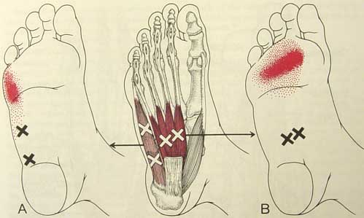
Trigger Pointers: Foot Intrinsics
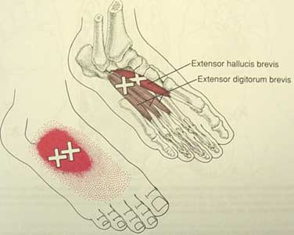
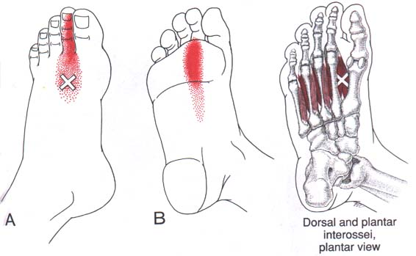
Summer is time for sandals. For some people, that means more foot pain because of trigger points in the little ‘intrinsic’ muscles of the foot. Although these muscles lie near the heel or in the middle of the foot, they tend to refer pain into the ball of the foot or the top of the foot. Pain at the ball of the foot may be diagnosed as metatarsalgia (i.e., pain over the metatarsals) or Morton’s neuroma (where a nerve gets pinched between the bones of the ball of the foot). Pain in the back to middle of the foot (often diagnosed as plantar fasciitis), is more likely to be caused by TrP in the gastrocnemius and soleus muscles, described in the August, 2007 newsletter available on-line at http://people.clarkson.edu/~lnrussek/FMSG.html).

Pain from TrP in the foot intrinsics is aggravated by walking, particularly walking in sand. When severe, the TrP may also present as deep aching pain at rest. The pain tends to be worse during the summer because sandals often don’t provide proper support or cushioning, plus we use our toes to hold some thong-type sandals on the feet. Ironically, once the TrP are active, pain may be aggravated by arch supports or shoes with good support that might have prevented development of these TrP. Tight shoes also aggravate these TrP; this may be more common in the summer when our feet swell and shoes that normally fit may be tight. People with particularly flat feet or high arches are both particularly vulnerable.
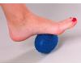
To avoid getting TrP in foot intrinsics, wear walking or running shoes that provide good arch support and cushioning and that aren’t too tight. Once you have TrP, you may need to inactivate the TrP before you can wear supportive shoes.
Although there are a lot of great foot massagers available for purchase, there are also quick and easy tools you can find around the home. Roll your foot over a golf, racquet, or tennis ball. You can ice and massage the muscles at the same time by rolling your foot over a frozen water bottle.
You can stretch the toe flexor muscles by hand by bending the toes back toward the top of the foot. Or, you can sit with your feet on the floor then lift your heels up off the floor until your toes are bent back. The toe extensors (which cause pain on the top of the foot) can be stretched by hand by pulling the toes down towards the ball of the foot.
Once the trigger points are not very painful, strengthening these muscles can help prevent the TrP from coming back. Pick up marbles or scrunch a towel with your toes to strengthen the toe intrinsic muscles.

July Potsdam Meeting:

The Potsdam Fibromyalgia Support Group July meeting will be Thursday, July 24th 6:30 pm in Clarkson Hall at 59 Main St.. This month’s discussion will be Summer Ice Cream Social. Make your own ice cream Sundae, or just come for the company and chance to talk. Family and friends invited. For more info, contact Canton-Potsdam Hospital Physical Therapy Department at 261-5460 or send an email Lnrussek@clarkson.edu.

Massena Group: Summer Vacation
The Massena Fibromyalgia Support Group will not meet during July and August. All members are welcome to attend the Potsdam meetings (car-pool!)


This newsletter is a joint effort of Clarkson University and Canton-Potsdam Hospital. If you would prefer to receive these newsletters electronically, please send your email address to gilberta@clarkson.edu. You can access current and previous Potsdam Fibromyalgia Support Group Newsletters on our web site: www.people.clarkson.edu/~lnrussek/FMSG.

